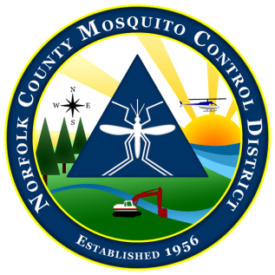
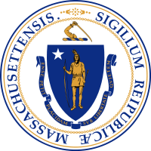

The Commonwealth of Massachusetts
The State Reclamation and Mosquito Control Board
Norfolk County Mosquito Control District
61 Endicott Street, Building #34, Norwood, MA 02062
(781) 762-3681 fax: (781) 769-6436
www.NorfolkCountyMosquito.org

Robin L. Chapell Norman P. Jacques Maureen P. MacEachern Linda R. Shea Richard J. Pollack, PhD
Commissioners

Caroline E. Haviland
Field Operations Manager
David A. Lawson
Director

Meeting Notice and Agenda of the Norfolk County Mosquito Control District Commission

4:00pm on May 25th, 2017 at District Headquarters

MEETING PREPARATION: No documents to review

AGENDA ITEMS THE CHAIR REASONABLY ANTICIPATES WILL BE DISCUSSED:

1. Approval of the minutes of the May 4th, 2017 Commission Meeting.

2. Budget Overview
a. FY 2017 budget review.
b. Headquarters relocation process

3. Fieldwork Overview
a. 2017 field work to date

4. Employee performance review and pay raise review

OTHER NOTES OR INFORMATION:

- New/Old Business or items to be put on next meeting’s agenda and items not anticipated.

