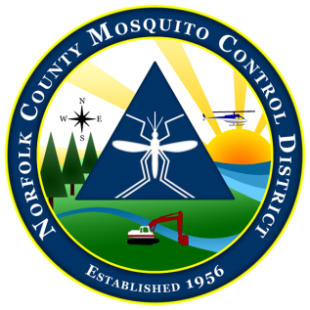
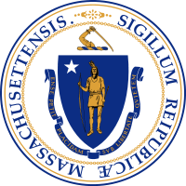

The Commonwealth of Massachusetts
The State Reclamation and Mosquito Control Board
Norfolk County Mosquito Control District
144 Production Road, Suite C, Walpole, MA 02081
(781) 762-3681 fax: (781) 769-6436
www.NorfolkCountyMosquito.org

Robin L. Chapell Norman P. Jacques Maureen P. MacEachern Linda R. Shea Richard J. Pollack, PhD
Commissioners

Caroline E. Haviland
Field Operations Manager
David A. Lawson
Director

Meeting Notice and Agenda of the Norfolk County Mosquito Control District Commission

4:00 pm on March 27th, 2019 at District Headquarters

MEETING PREPARATION:

AGENDA ITEMS THE CHAIR REASONABLY ANTICIPATES WILL BE DISCUSSED:

1. Approval of the minutes of the February 21st, 2019 Commission Meeting.

2. Budget Overview
a. Review of FY2019 expenses.

3. Fieldwork Overview
a. Year to date review.
b. Drone usage proposal.
c. Aerial larvicide preparation.

OTHER NOTES OR INFORMATION:

- New/Old Business or items to be put on next meeting’s agenda and items not anticipated.

