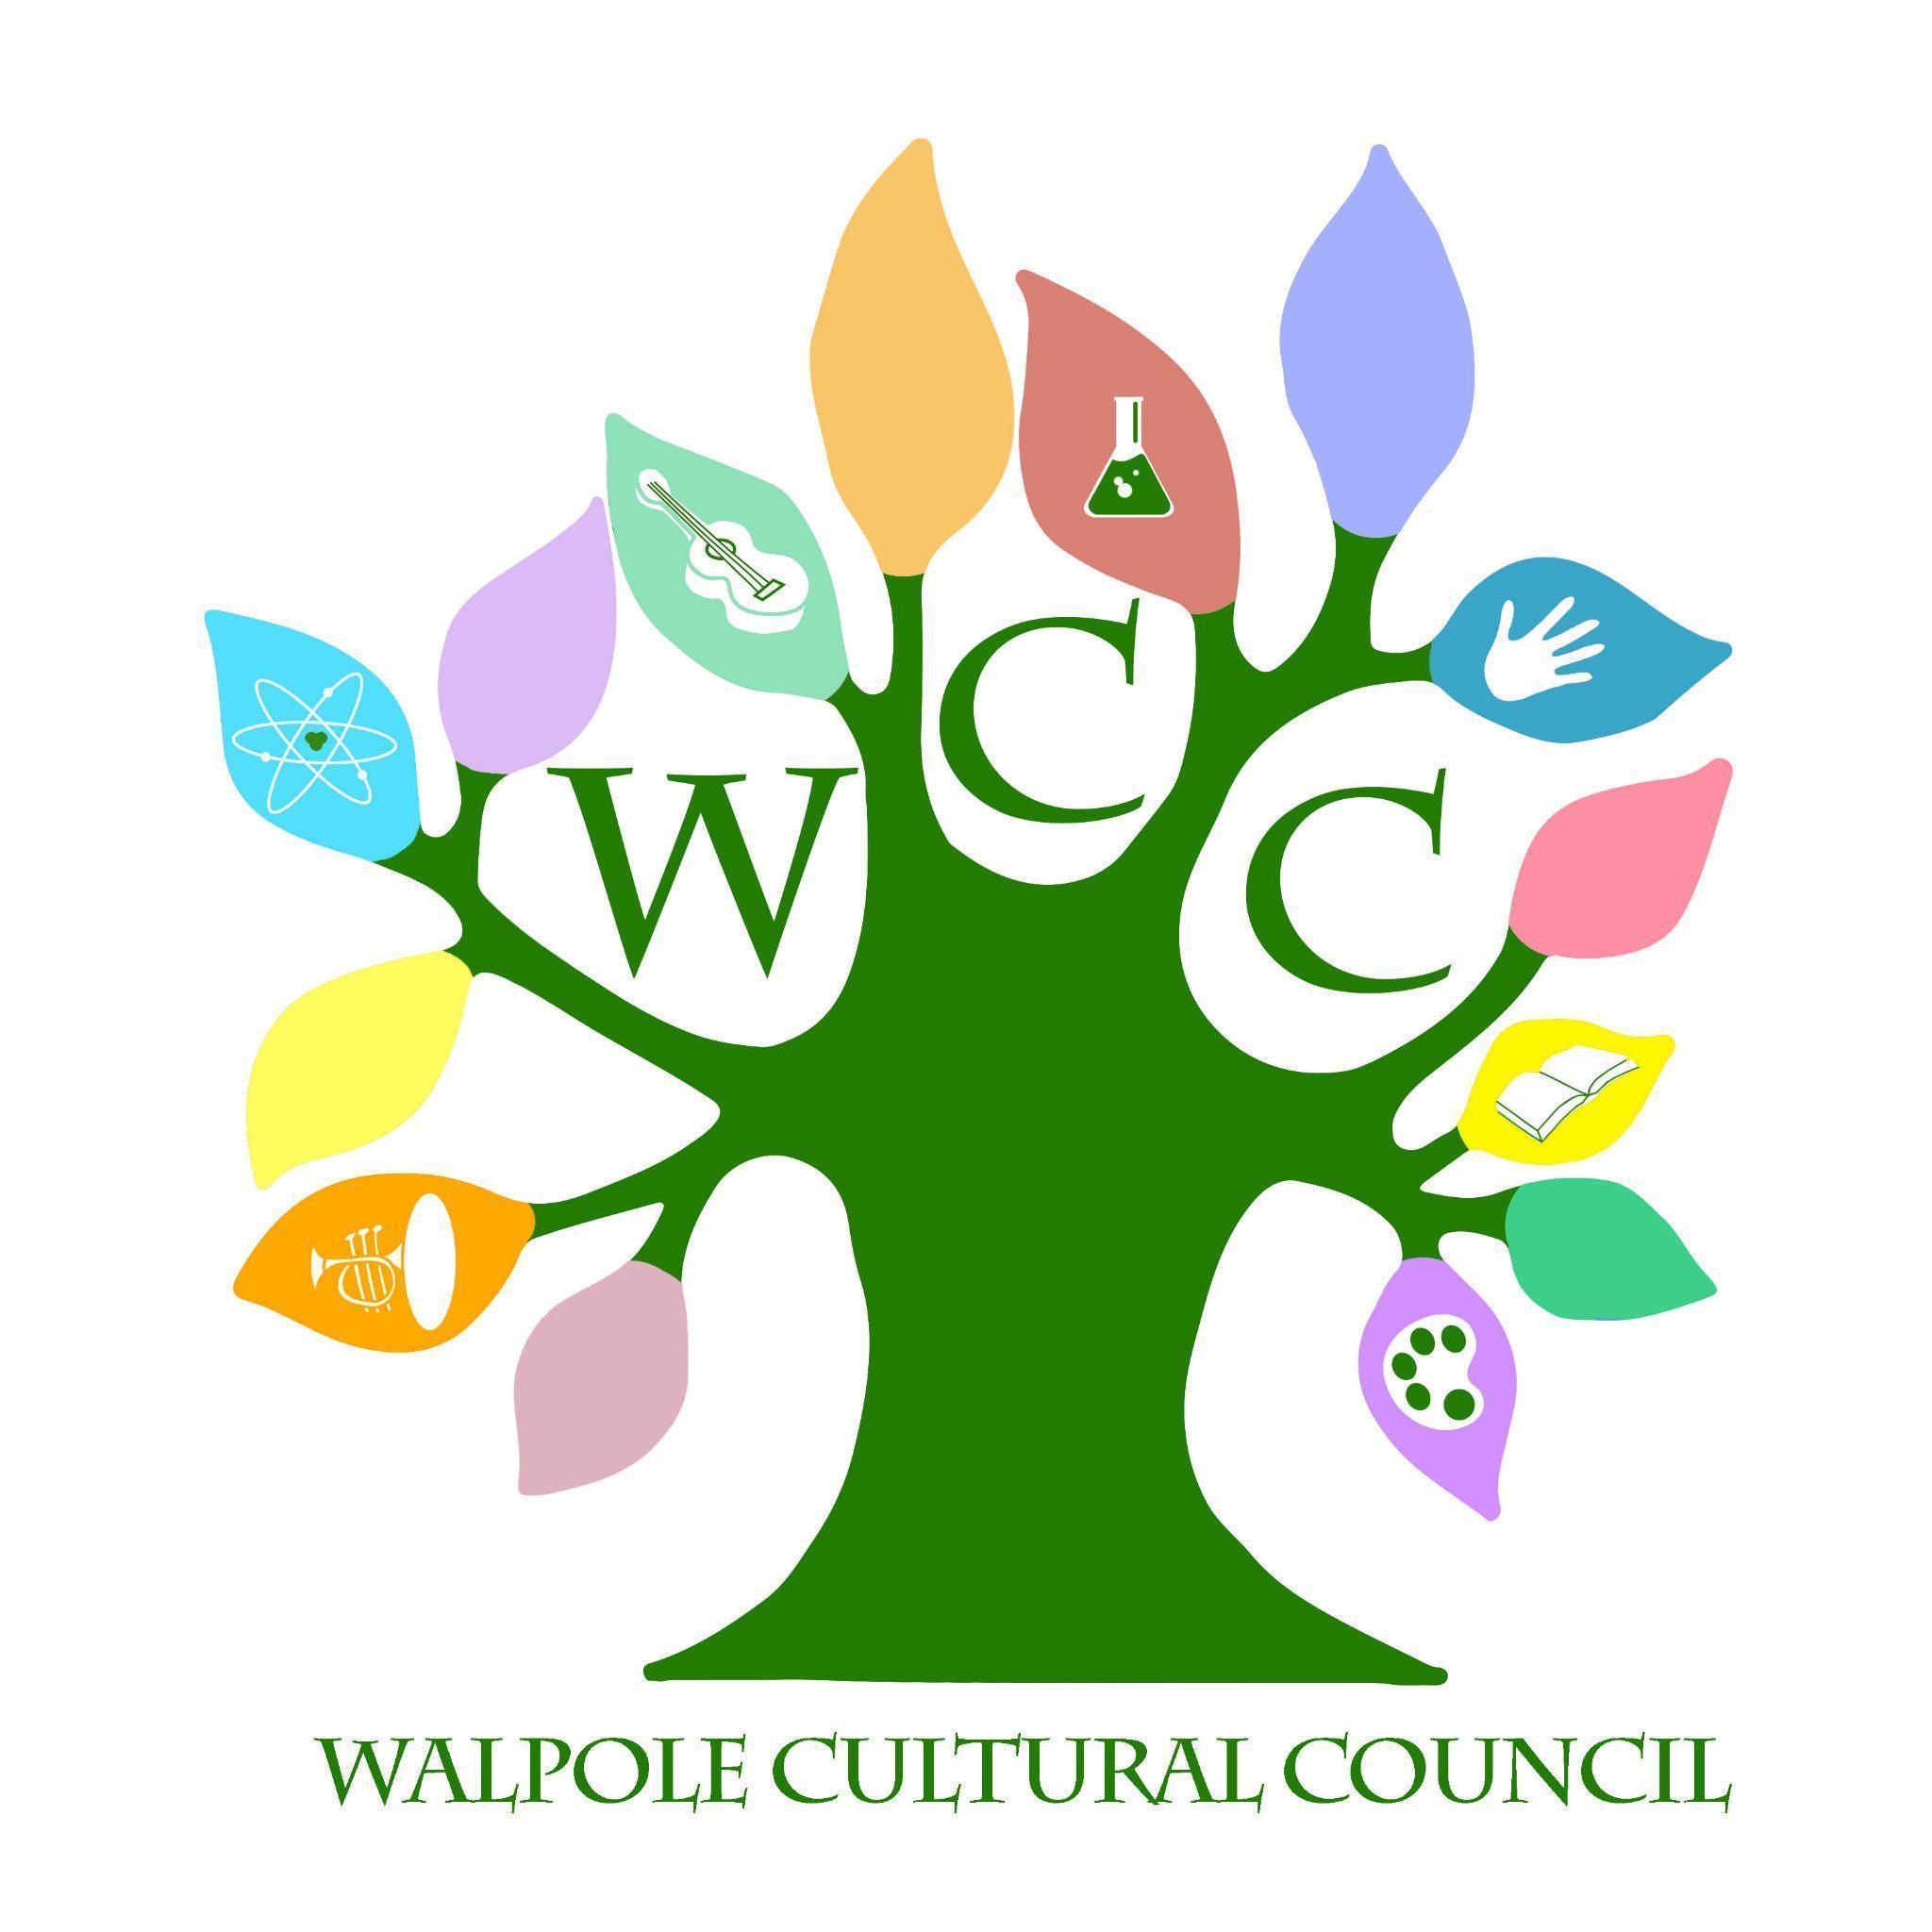
Walpole Cultural Council
November 16, 2022- 6:30 pm- Walpole Public Library
Agenda

- Call to Order
- Review Last Meeting Minutes
- Treasurer Report
- Walpole Writes
- Grants
- Administrative Items
- New Business
- Next Meeting Dates

