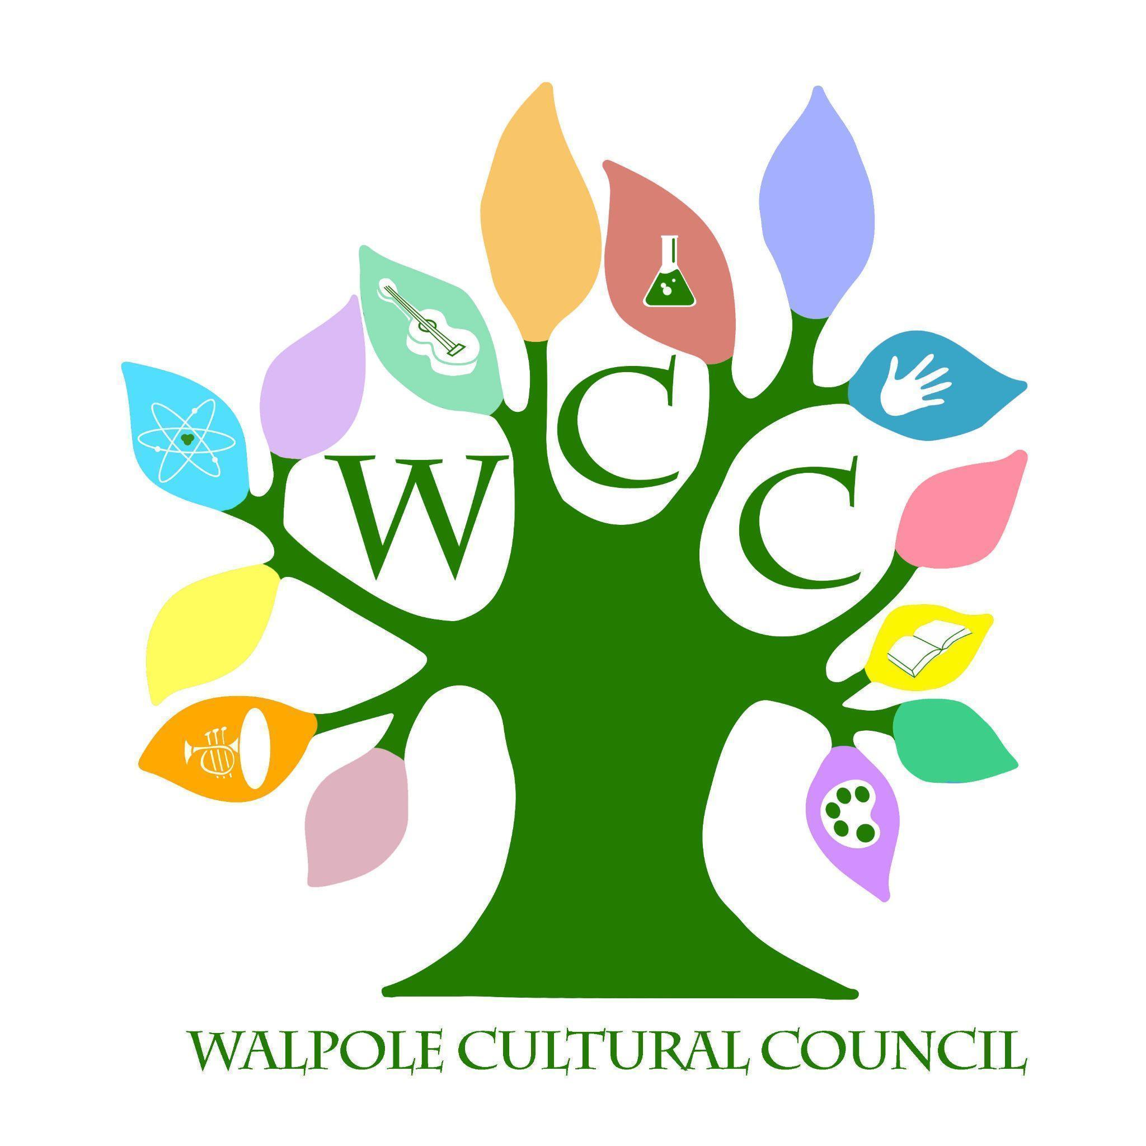
Walpole Cultural Council
4/19/23 6:30 pm- Walpole Public Library- Walpole Room
Agenda

Call to Order

Review Last Meeting Minutes

Treasurer Report

Grants
- MCC Funding

Walpole Writes

Municipal Efforts

Administrative Items
- Transitions

New Business

Next Meeting Date- 5/17

