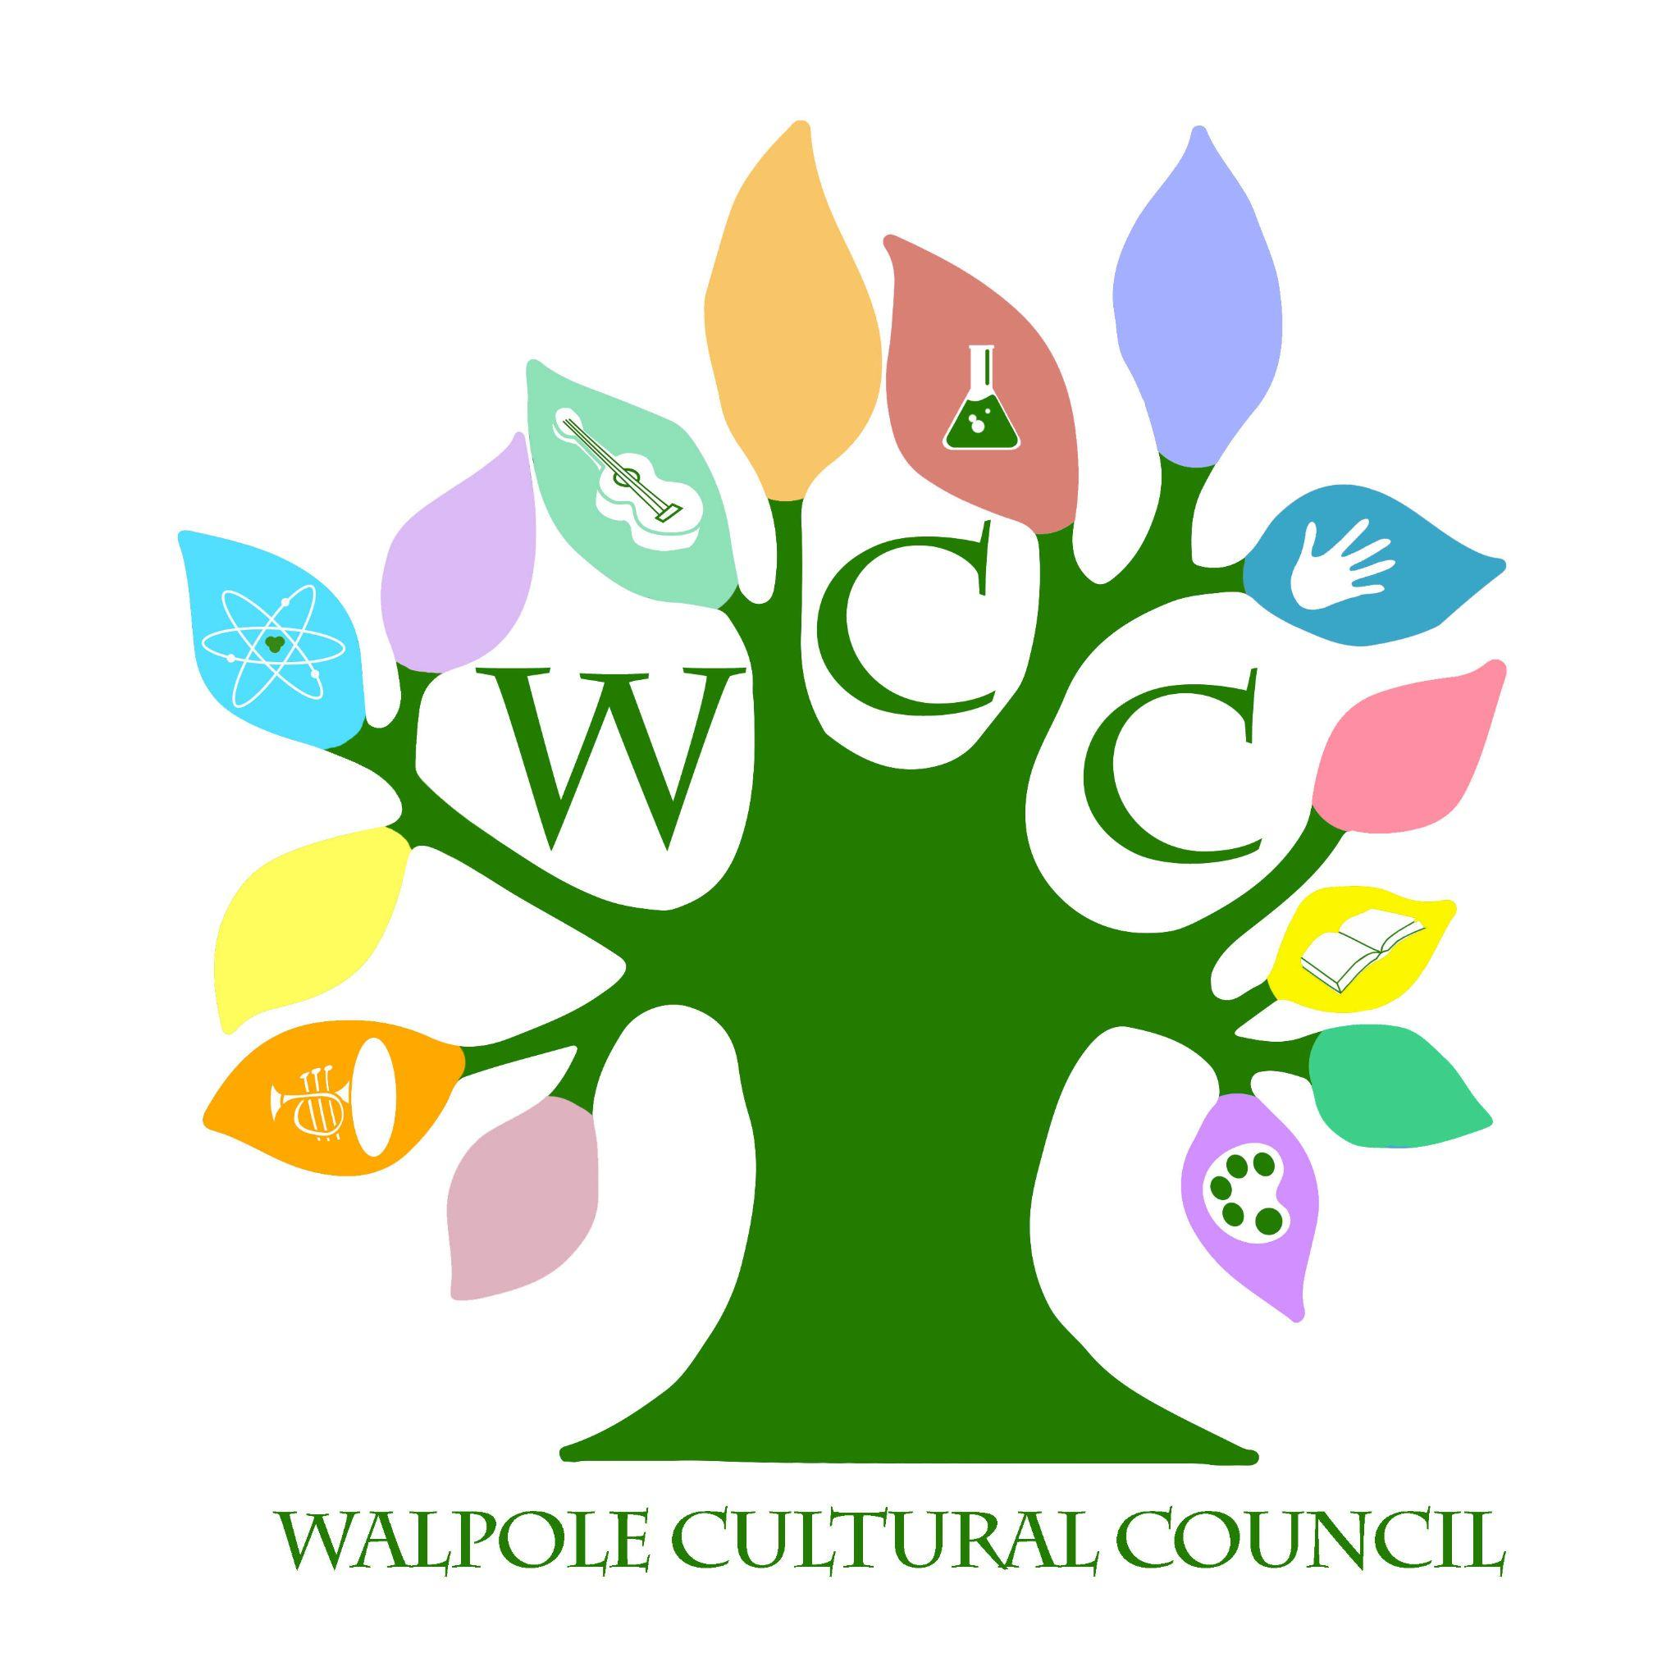
Walpole Cultural Council
September 21, 2022- 6:30 pm- Walpole Public Library Pinnacle Room

Agenda

- Call to Order

- Review June Minutes

- Treasurer Report
  - Discussion of and vote on holding 5% of allocated funds for WCC programming

- Walpole Writes
  - Final costs for book production
  - Followup on distribution of winner’s copies

- Grants
  - Discussion of and vote on any WCC programming for the 2022-2023 grant cycle
  - Press release

- Goals for 2022

- Administrative Items

- New Business

- Next Meeting Dates

