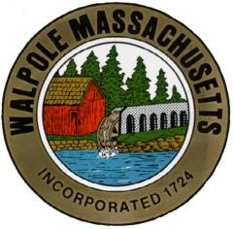
The Town of Walpole
Commonwealth of Massachusetts
Walpole Veterans Service Committee
Agenda – September 13, 2022 @ 6:00 pm.
Location: COA
1800: Call to order. Pledge of Allegiance.

1805: VSO Update
- Account balances
- Gift cards issued/remaining

1810: Old Business
- Memorial Day – after action report
  - Audience could not hear speakers – 2nd/3rd speaker/amplifier for Veterans day
- HTH Banner update
  - Order placed for Veteran’s day?
  - Sponsor banner updated?
  - Retirement of last year’s banners – how to respectfully do this
- Updated WVSC brochure – still waiting to see if David has the file

1810: New Business
- New Chair
- Secretary/Minutes
- Veterans Day
  - Speaker - Mark
  - Scouts
  - Vehicles - Mark
  - JWCW - Mark
  - Sound system/podium (additional speakers) - Rich
  - WHS Band - Mark
  - Taps/Echo/drum roll - Mark
  - Names of deceased since Memorial day - Mark
  - Flyer for publication – Rita
  - Banners including updated sponsorship banner - Stacey

1850 Looking forward
- Fundraising – Lorraine/Rich
- In memoriam donations to HTH - Rita
- Welcome Home program - Stacey

Submitted,
Rita Mienscow
Chair, Walpole Veterans Service Committee

