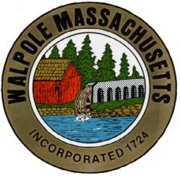
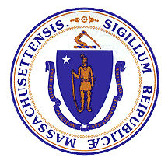
The Town of Walpole
Commonwealth of Massachusetts
Walpole Veterans Service Committee
Agenda – November 1, 2022

Call to order/Pledge of Allegiance

Review/acceptance of previous meeting minutes
VSO Update

Old Business
- Hometown Heroes banner program
  - For Veteran’s day swap: 18 banners, 16 brackets. Two applicants will be moved to Memorial Day.
  - Retired banners will be rolled, labeled and returned to families during ceremony (Rita) with the assistance of four scouts (two girls/two boys)
  - Stacy to present new banners with special mention to 100 year old Coast Guard Veteran.
  - 2 additional brackets will be ordered. One set for relocation of Civil/Revolutionary war banner.
  - Stacy to create poster board for sponsors for display day of event.
  - Reimbursement owed to Stacy for payment of banners.
  - Stacy - update banner application form to include donation information
  - Rita - “in lieu of flowers” HTH donation information for Walpole funeral homes
  - Stronger donation publicity

Veterans Day
- Attending guest/speaker: Congressman Stephen Lynch
- Guest speaker: James Jones, Major, United States Arm/Retired
- Names of deceased – Mark will provide
- Flyer – Donna to request publication in Hometown Weekly
- Rich/Mark to transport military branch flags to common (with sandbags)
- Extra chairs needed for families attending for new and retired HTH banners.
- WVSC to donate $300 to VFW to support Veterans day BBQ.

On-going
- Associate Chair
- Vacant position
- Fund raising – Kevin to review fund raising options for non 501(c)(3).
- WVSC pamphlet – needs updating – Saylor Murphy to assist with creating document. Rita to provide information/photos.

New business
- Fundraising planning
- Welcome Home Program
- Donna to coordinate gift for recently resigned WVSC member for presentation on Veterans Day

Submitted,
Rita Mienscow
Chair, Walpole Veterans Service Committee

