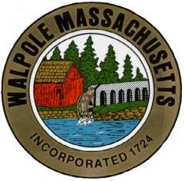
The Town of Walpole
Commonwealth of Massachusetts
Walpole Veterans Service Committee
Agenda – May 17, 2022 @ 6:00 pm.

Location: COA, South Street
1800: Call to order. Pledge of Allegiance.

1805: Review/acceptance of previous meeting minutes
1810: VSO Update

1820: Old Business
- Hometown Heroes banner program - updates
- Flag Swap – May 14
- Memorial Day – May 30
- Walpole Day – June 11

1850 Fundraising – Cedar House
High School student involvement (cemetery footstones)

Submitted,
Rita Mienscow
Chair, Walpole Veterans Service Committee

