Neponset Stormwater Partnership

Annual Report

July 1, 2022 through June 30, 2023

Introduction 4
Participating Communities and Organizations 4
Project Funding 4
Note About Using the NSP Annual Report 5
MCM1 Public Education 6
Public Education BMP 1: Maintain Educational Website 6
Public Education BMP 2: Operate Stormwater Hotline 6
Public Education BMP 3: Distribute Pet Waste Information With Dog Licenses 8
Public Education BMP 4: Summer Pet Waste Campaign 9
Public Education BMP 5: Fall Leaf Waste Campaign 12
Public Education BMP 6: Spring Fertilizer and Grass Clipping Campaign 16
Public Education BMP 7: School Outreach Program 19
Public Education BMP 8: Regional Education Mailing 20
Public Education BMP 9: Outreach to Septic System Owners 21
Public Education BMP 10: “Problem Area” Outreach 24
Public Education BMP 11: Storm Drain Marking 25
Public Education BMP 12: Regional Water Quality Forum 26
Public Education BMP 13: Regional Water Quality Data Reports and Press Releases 27
Public Education BMP 14: Educational Outreach Evaluation 28
Public Education BMP 15: Stormwater Educational Presentations 29
Public Education BMP 16: Developer and Construction Outreach 30
Public Education BMP 17: Industrial Outreach 31
MCM 2: Public Participation 33
General Public Participation Activities 33
Public Participation BMP 1: River Clean Up Days 33
Public Participation BMP 2: Volunteer Water Quality Monitoring Program 33
Public Participation BMP 3: Regional Water Quality Forum 33
MCM 3: Illicit Discharge Detection and Elimination 34
Illicit Discharge Detection and Elimination BMP 1: IDDE Training 34
MCM 4: Construction Erosion and Sediment Control 34
Construction Erosion and Sediment Control BMP 1: Existing Bylaw and Regulation Review 34
MCM 5: New Development and Redevelopment 34
New Development and Redevelopment BMP 1: Existing Bylaw and Regulation Review 34
New Development and Redevelopment BMP 2: Zoning and Bylaw Analysis 34
New Development and Redevelopment BMP 3: Evaluation of Retrofit Tools 34
MCM 6: Good Housekeeping and Pollution Prevention 36
Activities Not Corresponding to an MCM 36
General Coordination and Training 36
Appendix A-1: Example Materials for Public Education BMP 3 38
Appendix A-2: Example Materials for Public Education BMP 4 39
Appendix A-3: Example Materials for Public Education BMP 5 40
Appendix A-4: Example Materials for Public Education BMP 6 42
Appendix A-5: Example Materials for Public Education BMP 7 44
Appendix A-6: Example Materials for Public Education BMP 8 47
Appendix A-7: Example Materials for Public Education BMP 9 48
Appendix A-8: Example Materials for Public Education BMP 11 54
Appendix A-9: Example Materials for Public Education BMP 12 55
Appendix A-10: Example Materials for Public Education BMP 13 68
Appendix A-11: Example Materials for Public Education BMP 14 71
Appendix A-12: Example Materials for Public Education BMP 16/17 79

Introduction

The Neponset Stormwater Partnership (NSP) is a regional stormwater collaborative which brings together communities in and around the Neponset River Watershed area. NSP members work together to reduce stormwater pollution and streamline compliance with the Small Municipal Separate Storm Sewer System (MS4) permit which is issued jointly by the U.S. Environmental Protection Agency (EPA) Region 1 and the Massachusetts Department of Environmental Protection (MassDEP).

This report covers activities completed by the NSP during the period July 1, 2022 to June 30, 2023.

This report is generally organized by the six minimum control measures (MCMs) outlined by the MS4 permit, subject to the caveat that some activities do not fit neatly into the framework established by the minimum control measures yet advance the goals of the permit.

Participating Communities and Organizations
The following communities and other organizations were active members of the NSP during the reporting period:

- Avon
- Canton
- Dedham
- Foxborough
- Medfield
- Milton
- Norwood
- Quincy
- Randolph
- Sharon
- Stoughton
- Walpole
- Westwood

The Neponset River Watershed Association serves as the overall coordinator for the NSP and coordinates or leads the implementation of many of the NSP’s priority tasks.

Unless otherwise noted, all participating communities participated in each of the tasks or activities described below.

Project Funding
The NSP is supported through matching contributions from the participating municipalities, and other matching grants and donations assembled by NepRWA.

Note About Using the NSP Annual Report
The NSP Annual Report provides a summary of all the work undertaken by the NSP during the report period. Some of this work, particularly in the areas of Public Education and Public Participation, is directly applicable to our member communities’ EPA annual reporting requirements.

In the Public Education and Participation sections of the NSP Annual Report, content has been formatted in a manner consistent with the format of the EPA annual report template. Because the NSP is a regional program, these sections are written from a “regional” perspective rather than “town-by-town” perspective. Where additional details of community-specific efforts are known, we have included these in summary form for those communities that prefer to report on a community-specific basis.

In past communication, EPA has endorsed the concept of a regional Education SWMP and a regional Education Annual Report. If a community is relying on the NSP to meet its Public Education requirements, they do not need to carefully justify community-specific results from the regional implementation activities, provided that the community was actively participating in NSP activities.

Rather, if a community has incorporated by reference the NSP Regional Outreach and Education SWMP into its own municipal SWMP, they can satisfy the education reporting requirement by referencing the NSP Annual Report by including the URL in their own annual report.

If a community has not adopted the NSP Regional Outreach and Education SWMP by reference, it may pick and choose from among the NSP’s completed education activities and add them directly to their own municipal EPA annual report.

Lastly, any number of other NSP activities may be indirectly or partially applicable to a community’s MS4 reporting requirements. These activities include areas such as
- Staff training that occurs during NSP meetings and workshops
- Technical assistance on bylaws, green infrastructure, or IDDE tools
- Water quality data which may be relevant to IDDE
- Evaluation and construction of stormwater retrofit opportunities.

Because these areas do not neatly match the applicable EPA reporting requirements for all NSP communities, they have not been formatted to correspond to the EPA annual report template. Rather, they are simply provided as brief narrative or bullets. However, NSP communities may still want to pick and choose activities in these sections that they would like to use to supplement their EPA annual report.

MCM1 Public Education

The NSP maintains several activities addressing Public Education and Participation requirements, including the continued development of a regional outreach program that produces educational material for use by all participating members.

Samples of outreach materials described below are either linked in the narrative (if available on the internet) or are included in the Appendix at the end of this document.

Public Education BMP 1: Maintain Educational Website

DDescription: | Maintained a comprehensive educational website to serve the Neponset Stormwater Partnership service area as a primary resource for key information for all four target audiences.
UTarget Audience: | Residents, Businesses, Institution, and Industrial
UMeasurable Goals: | Achieve at least 500 unique site visits every year.
UResults: | This year, there were 4,116 unique site visitors and 6,321 page views.
UDate(s): | Ongoing since May 1, 2018
UApplies to Appendix F (TMDL): | Yes (pet waste, fertilizers, leaves and grass clippings, septic)
UApplies to Appendix H (WQ Limited Waters): | Yes (pet waste, fertilizers, leaves and grass clippings, septic)
UExample Materials: | 26TUwww.yourcleanwater.orgU26T

Public Education BMP 2: Operate Stormwater Hotline

Description: | Operated a regional “stormwater hotline” to field questions and problem reports regarding stormwater from across the region. Reports were collected via a website form hosted at yourcleanwater.org, via email submissions to stormwater@neponset.org, and phone calls to 781-575-0354 x 300. Responses to reports included answers to questions, additional information or follow up investigation, and/or referral of inquiries/reports to the appropriate municipalities. Anonymity of inquiries was maintained as requested.
Target Audience: | Residents, Businesses, Industry, and Developers
Measurable Goals: | Provide immediate answers to inquiries generated by regionalized outreach activities.
Results: | Four reports were made to the stormwater hotline this year concerning:  - A report of a Milton resident dumping trash into a storm drain and staging trash and recycling directly over the storm drain well before trash pickup. With consent from the Town of Milton, NepRWA installed two storm drain markers, asked DPW to place orange cones over the drains to deter residents from staging trash on the storm drains, and delivered a letter to all residents of the cul-de-sac providing information about storm drains and best practices for residential stormwater management. Additionally, NepRWA and Town of Milton staff spoke directly to residents about the issue.  - Gray/white water in the East Branch of the Neponset River in Stoughton. NepRWA staff determined the source was an illicit discharge to a storm drain by a drilling company installing a well nearby. Stoughton Conservation Commission was notified, and the problem was addressed by mulching the disturbed area, installation of a catch basin silt sack proprietary SWBMP, and re-inspection of the stream. A pile of sand was frozen adjacent to the catch basin and the management team was directed to move it from the site upon thawing. The well driller was given a warning.  - Pet waste not being properly picked up on walking trails around Adams Farm in Walpole, MA. NepRWA provided five double sided laminated educational flyers to be put up at the owner’s discretion.  - Stockpiles of sand observed in the parking lot of Ponkapoag Golf Course in Canton. Photos were sent to the Conservation Commission and showed fine particles moving towards a nearby storm drain. The Conservation Commission immediately took action, and the stockpiles were removed.
Date(s): | Ongoing since May 1, 2018
Applies to Appendix F (TMDL): | N/A
Applies to Appendix H (WQ Limited Waters): | N/A
Example Materials: | N/A

Public Education BMP 3: Distribute Pet Waste Information with Dog Licenses

Description: | Educational “rack cards” regarding proper pet waste disposal were printed and provided to town clerks’ offices in member towns to distribute with dog licenses, either in person or via mail. The number of rack cards distributed correlated to the number of dogs licensed per town to ensure all dog owners received the information. In towns where online renewal is available, online graphics that link to the pet waste page of the NSP website were provided.
Target Audience: | Residents
Measurable Goals: | Participation by 100% of Town Clerks to reach 80% of dog owners annually with pet waste management information. Over the 5-year permit period achieve a reduction in the number of pet waste bags found when cleaning catch basins in the member communities that track this information.
Results: | All Towns participated in pet waste messaging. A total of 7,100 cards were requested by Town Clerks and distributed accordingly. A graphic with a link to a “Pet Waste” focused webpage on the YourCleanWater.org website was included for online renewals in the Town of Sharon. Additionally, the Town of Randolph provided a pet waste message to all dog owners by printing it directly on the license receipt and the Town of Milton uses a scan of the rack card to include in their annual census. These methods are estimated to have reached the entire population of dog owners in participating towns.
Date(s): | Materials were distributed to Town Clerks in November and December 2022 and disseminated to dog owners as licenses were issued throughout the year.
Applies to Appendix F (TMDL): | Yes
Applies to Appendix H (WQ Limited Waters): | Yes
Example Materials: | 26TAppendix A-126T

Public Education BMP 4: Summer Pet Waste Campaign

Description: |  | Prepared one paid Facebook/Instagram ad campaign about the proper disposal of pet waste. Additionally, the same messaging was shared as a social media post to the Neponset River Watershed Association’s social media accounts including Facebook, Instagram, and Twitter. Neponset Stormwater Partnership member communities were asked to share/retweet it on their own social media accounts where available. Additionally, towns were tagged on their respective town accounts (where available) for ease in distribution. Below highlights the days posted, content, and reach. (Note that Twitter posts were shortened to meet character requirements.)  The social media post read as follows on July 12, 2022: “Pet waste contains bacteria and parasites that get washed to the nearest waterway when it rains.  Every time you walk your dog, please:  - carry a bag to pick up pet waste,  - dispose of waste in a trash can,  - never toss anything down a storm drain!  Learn more about keeping your local waterways clean at yourcleanwater.org”
Additional Town-Specific Details: | Avon:  Canton: | The paid Facebook ad campaign reached 2,482 Avon residents.  The Town of Canton shared the social media message was shared by the Canton Conservation Commission Facebook account with the following message “1600 registered dogs in Canton, ¾ pounds of poop per dog per day means OVER 400,000 pounds of dog poop produced in Canton per year. Our rivers and streams are unswimmable due to E. coli bacteria. Do your part as a community member and properly dispose of your dog’s waste. All storm drains lead to our stream and rivers.” Additionally, the paid Facebook ad campaign reached 11,816 Canton residents.
 | Dedham: | The Town of Dedham reshared the social media post by the Town of Dedham DPW Facebook page with the following message: “Pet waste is a major source of pollution to our waterways!! Please do your part to pick up after your pets and to properly dispose of the waste!!” Additionally, the information was shared by the Town Engineering Department Twitter account, and the Town’s Instagram account. The paid Facebook ad campaign reached 15,184 Dedham residents.
 | Foxborough: | The Town of Foxborough reshared the social media post on the Town of Foxborough’s DPW Facebook page and the Foxborough Conservation Commission Facebook. Additionally, the paid Facebook ad campaign reached 8,056 Foxborough residents.
 | Medfield: | The paid Facebook ad campaign reached 5,888 Medfield residents.
 | Milton: | The Town of Milton reshared the social media post on the Town of Milton Facebook page. The paid Facebook ad campaign reached 11,652 Milton residents.
 | Norwood: | The Town of Norwood reshared the social media post on the Norwood Conservation Commission Facebook page. Additionally, the paid Facebook ad campaign reached 16,800 Norwood residents.
 | Quincy:  Randolph: | The City of Quincy liked the NepRWA Twitter post.  The Town of Randolph used the social media post as content for their town website under Stormwater. Additionally, the paid Facebook ad campaign reached 15,700 Randolph residents.
 | Sharon: | The Town of Sharon reshared the social media posts on the Town’s Facebook and Twitter account. Additionally, the paid Facebook ad campaign reached 7,098 Sharon residents.
 | Stoughton:  Walpole:  Westwood: | The Town of Stoughton reshared the social media post on the Stoughton Recreation Department Facebook page. Additionally, the paid Facebook ad campaign reached 14,680 Stoughton residents.  The Town of Walpole signed on for paid social media outreach in December 2022. Therefore, NepRWA ran the Walpole paid Facebook ad campaign from January 27- February 24, 2023, which coincided with most pet license renewals. The paid Facebook ad campaign reached 17,734 Walpole residents.  The paid Facebook ad campaign reached 7,046 Westwood residents.
Target Audience: |  | Residents
Measurable Goals: |  | Participation by 100% of NSP communities and reach at least 1,000 people in the NSP region through social media.
Results: |  | NSP communities participated by redistributing one or more of the campaign materials with most communities participating in multiple distribution methods. The paid Facebook Ad Campaign reached a total of 114,464 people in participating towns, 2,792 through NepRWA’s Facebook post, 1,393 people through NepRWA’s Twitter account, and 101 through NepRWA’s Instagram account
Date(s): |  | July 5 through July 29, 2022.  Paid ad ran January 27 through February 24, 2023 in Walpole only
Applies to Appendix F (TMDL): |  | Yes
Applies to Appendix H (WQ Limited Waters): |  | Yes
Example Materials: |  | 26TAppendix A-226T

Public Education BMP 5: Fall Leaf Waste Campaign

Description: | Prepared one paid Facebook/Instagram ad campaign about the proper disposal of leaf waste. Additional social media materials were posted to the Neponset River Watershed Association’s social media accounts including Facebook, Instagram, and Twitter. Neponset Stormwater Partnership member communities were asked to share/retweet it on their own social media accounts where available. Additionally, towns were tagged on their respective town accounts (where available) for ease of distribution. Below highlights the days posted, content, and reach. (Note that Twitter posts were shortened to meet character requirements.)  The following social media messages were posted throughout the campaign period:  - The October 5, 2022, social media post reached 539 on Facebook, 837 on Twitter, and 79 on Instagram. The post read as follows:  “Cleaning out your catch basins of leaves and other debris can reduce flooding in your neighborhood and keep trash from entering our waterways.  For more tips on managing your yard waste visit: https://yourcleanwater.org/yard-waste-disposal/”  - The October 11, 2022 social media post reached 143 on Facebook, 198 on Twitter, and 86 on Instagram. The post read as follows:  “You've raked your leaves! Now what?  Know how to properly dispose of yard waste in your town by following this link! Properly disposing of leaves can reduce water pollution and prevent flooding.  https://yourcleanwater.org/yard-waste-disposal/”  - The October 17, 2022, social media post reached 534 on Facebook, 1,145 on Twitter, and 89 on Instagram. The post read as follows:  “Don't forget to add leaves to your compost!  Composting with leaves contribute to healthy nutrient rich soil. Many composting companies have started servicing towns and cities within the watershed and do leaf pick-up during the fall months!  For more information on proper leaf and yard waste disposal visit: https://yourcleanwater.org/yard-waste-disposal/ “  - The October 25, 2022 social media post reached 1,124 on Facebook, 1,123 on Twitter, and 148 on Instagram. The post read as follows:  “As leaves and grass clippings decay, they release nutrients that can cause harm to our waterways. If the decay happens in water, such as a slow-flowing stream, it also uses up oxygen in the water and suffocates organisms that need it.  If you are concerned about improper leaf disposal in your neighborhood please feel free to report it anonymously to our Stormwater Hotline by either visiting https://yourcleanwater.org/report/ or calling us at 781-575-0354 x 300”
Additional Town-Specific Details: |  | Avon:  Canton: | The paid Facebook/Instagram social media campaign reached 2,420 Avon residents.  The paid Facebook/Instagram social media campaign reached 11,392 Canton residents.
 |  | Dedham: | The Town of Dedham liked the Twitter social media post from 10/5 on the Dedham-Westwood Water District Twitter account. Additionally, the DPW posted information on their Facebook page about properly disposing of yard waste during the month of October 2022 and the Engineering Department tweeted the same message. NepRWA also provided PDF flyers for Dedham to distribute through the Town’s website, DPW Facebook page, and the Engineering Department Twitter account. The paid Facebook/Instagram social media campaign reached 15,252 Dedham residents.
 |  | Foxborough: | The Town of Foxborough shared the Facebook social media post on 10/5 to the Conservation Commission Facebook account page and liked the Twitter post from 10/11. Additionally, they posted information about 5 ways to use fallen leaves on Facebook. This included composting, leaf molding, mulching, spreading, and insulation. The paid Facebook/Instagram social media campaign reached 8,044 Foxborough residents.
 |  | Medfield: | NepRWA provided PDF flyers for Medfield to distribute. The paid Facebook/Instagram social media campaign reached 5,488 Medfield residents.
 |  | Milton: | The Town of Milton shared the Facebook social media post from 10/5 on the Town of Milton DPW account page. The official Town’s Twitter page reshared the post from 10/24. Additionally, the paid Facebook/Instagram social media campaign reached 11,820 Milton residents.
 |  | Norwood: | The Town of Norwood shared the Facebook social media posts from 10/5 and 10/24 on the Norwood Conservation Commission account page. on the Town’s Facebook and Twitter accounts. The Town’s official Facebook page shared the 10/24 post and shared the 10/5 post to their Twitter account. In addition, the Conservation Commission shared several messages on their Facebook page regarding cleaning catch basins, composting leaves, and promoting the Stormwater Hotline as an avenue to report improper yard waste disposal. The paid Facebook/Instagram social media campaign reached 16,920 Norwood residents.
 |  | Quincy: | The City of Quincy shared the Twitter social media posts from 10/5, 10/17, and 10/24. Additionally, they posted about their yard waste pickup schedule in October 2022 on their city Facebook page.
 |  | Randolph: | The paid Facebook/Instagram social media campaign reached 15,351 Randolph residents.
 |  | Sharon: | The Town of Sharon shared the Facebook and Twitter post from 10/24 on their official Town account. The paid Facebook/Instagram social media campaign reached 6,962 Sharon residents.
 |  | Stoughton: | The Town of Stoughton posted on a flyer on the Town’s Stormwater webpage. The paid Facebook/Instagram social media campaign reached 13,936 Stoughton residents.
 |  | Walpole:  Westwood: | The Town of Walpole signed on for paid social media outreach in December 2022. Therefore, NepRWA ran a paid social media campaign for yard cleanup from May 8 through June 2, 2023. The paid Facebook ad campaign reached 16,396 Walpole residents.  The Town of Westwood liked the Twitter post from 10/5 from their Dedham-Westwood Water District account. The paid Facebook/Instagram social media campaign reached 6,430 Westwood residents.
Target Audience: | Residents
Measurable Goals: | Participation by 100% of NSP communities and reach to at least 1,000 people in the NSP region through social media.
Results: | NSP communities participated by redistributing one or more of the campaign materials, or by using previously prepared town materials, with most communities participating in multiple distribution methods. The paid Facebook and Instagram Ad Campaigns reached a total of 107,231. Additionally, NepRWA made four additional posts on our Facebook, Instagram, and Twitter pages resulting in a reach total of 2,296 on Facebook, 399 through Instagram, and 3,236 people through Twitter.
Date(s): | October 2022; Walpole May 8 through June 2, 2023
Applies to Appendix F (TMDL): | Yes
Applies to Appendix H (WQ Limited Waters): | Yes
Example Materials: | 26TAppendix A-326T

Public Education BMP 6: Spring Fertilizer and Grass Clipping Campaign

Description: |  | Prepared one paid Facebook/Instagram ad campaign directed at the proper disposal of leaf waste. Additional social media materials were posted to the Neponset River Watershed Association’s social media accounts including Facebook, Instagram, and Twitter. Neponset Stormwater Partnership member communities were asked to share/retweet it on their own social media accounts where available. Additionally, towns were tagged on their respective town accounts (where available) for ease of distribution. Below highlights the days posted, content, and reach. (Note that Twitter posts were shortened to meet character requirements.)  The social media post on April 10, 2023 reached 1,006 on Facebook, 467 on Twitter, and 205 on Instagram. The post read as follows:  “Please don't 'P' on your lawn! We know better!  Adding fertilizer with phosphorous (P) is illegal in Massachusetts without a soil test stating it is necessary. UMass Amherst offers convenient soil testing options.  For more information regarding testing and application visit: https://yourcleanwater.org/lawn/”  A second post regarding fertilizer use was also shared across NepRWA’s social media platforms on April 20, 2023. Similarly with the intent that town’s had multiple options for sharing/retweeting.. The fertilizer and lawn care section of the NSP website was included in the post. Below highlights the days posted, content, and reach. Please note that Twitter posts were shortened in order to meet character requirements, however the content was similar to what is described below.  The social media post reached 2,258 on Facebook, 955 on Twitter, and 195 on Instagram. The post read as follows:  “Be careful where you put your lawn fertilizer! Rain or irrigation runoff can wash fertilizer into ponds and streams - and harm fish and wildlife, cause smelly algae blooms, and affect our drinking water.  Learn more about how to protect our waterways at: https://yourcleanwater.org/lawn/”
Additional Town-Specific Details: | Avon:  Canton: | The paid Facebook/Instagram social media campaign reached 3,142 Avon residents.  The Town of Canton shared their own fertilizing message on their Town website and on the Town select board website. The paid Facebook/Instagram social media campaign reached 14,204 Canton residents.
 | Dedham: | The Town of Dedham shared the social media post from 4/10 on the Town’s Engineering Department Twitter and shared and liked on the Official Town Twitter page. The 4/20 post was reshared on the Town of Dedham DPW and Official Town Facebook pages and retweeted on the Town of Dedham DPW, Engineering Department, and Official Town Twitter pages. The paid Facebook/Instagram social media campaign reached 18,375 Dedham residents.
 | Foxborough: | The Town of Foxborough shared the social media post from 4/10 on the Town’s DPW and Conservation Commission Facebook page. The paid Facebook/Instagram social media campaign reached 9,060 Foxborough residents.
 | Medfield: | The paid Facebook/Instagram social media campaign reached 10,904 Medfield residents.
 | Milton: | The Town of Milton shared the social media post from 4/20 on the Town of Milton DPW Facebook page and reshared content on their official town Twitter page. The paid Facebook/Instagram social media campaign reached 14,468 Milton residents.
 | Norwood: | The Town of Norwood shared the social media post from 4/20 on the Town’s Conservation Commission Facebook page. The paid Facebook/Instagram social media campaign reached 19,916 Norwood residents.
 | Quincy: | N/A
 | Randolph: | The paid Facebook/Instagram social media campaign reached 18,164 Randolph residents.
 | Sharon: | The Town of Sharon shared the social media post from 4/20 on the Town’s Facebook page. The paid Facebook/Instagram social media campaign reached 7,471 Sharon residents.
 | Stoughton: | The Town of Stoughton shared the social media post from 4/20 on the Public Works and Recreation Department’s Facebook pages. The Town requested a flyer with fertilizer and lawn maintenance information, which they posted online and in a few public offices. The paid Facebook/Instagram social media campaign reached 16,740 Stoughton residents.
 | Walpole:  Westwood: | The paid Facebook/Instagram social media campaign reached 13,408 Walpole residents.  The Town of Westwood shared the social media post from 4/20 Town’s Facebook page and liked the post on Twitter. The paid Facebook/Instagram social media campaign reached 7,722 residents.
Target Audience: |  | Residents,
Measurable Goals: |  | Participation by 100% of NSP communities and reach to at least 1,000 people in the NSP region through social media.
Results: |  | NSP communities participated by redistributing one or more of the campaign materials with most communities participating in multiple distribution methods. A total of 153,574 people were reached through the paid Facebook Ad Campaign 3,264 via the two Facebook social media posts, 1,422 via the two Twitter posts, and 400 between the two Instagram posts.
Date(s): |  | April 10 – May 6, 2023
Applies to Appendix F (TMDL): |  | Yes
Applies to Appendix H (WQ Limited Waters): |  | Yes
Example Materials: |  | Appendix A-426T

Public Education BMP 7: School Outreach Program

Description: | During the 2022-2023 school year all lessons took place in person. The program focused on drinking water, stormwater infrastructure, local water resources, wastewater systems, water conservation, and stormwater pollution prevention techniques, and the curriculum aligned with the MA 5P^{th}P grade science curriculum standards. Information was presented using a PowerPoint presentation, a groundwater model, and an enviroscape model. The program was delivered at the individual classroom level by a watershed educator over the course of ONE VIST (Avon, Norwood, Quincy) or TWO VISITS (Canton, Foxborough, Medfield, Milton, Sharon, Stoughton, Dedham, Walpole, and Westwood). Each visit took 45-60 minutes. The educator also provided teachers with follow-up materials to share with students and families.
Target Audience: | Residents
Measurable Goals: | Reach at least 80% of households with 5P^{th}P grade children in participating communities, and 100% positive feedback from participating classroom teachers.
Results: | During the 2022-2023 school year a total of 266 classrooms were visited, representing an estimated 3,000 families. (52 classes were visited once and 107 classrooms were visited twice.) Feedback from teachers was exceedingly positive for the on-line and in-person presentation materials.
Date(s): | September 2022 through June 2023
Applies to Appendix F (TMDL): | N/A
Applies to Appendix H (WQ Limited Waters): | N/A
Example Materials: | 26TAppendix A-526T  Water Conservation and Stormwater PowerPoint Slides are available upon request.

Public Education BMP 8: Regional Education Mailing

Description: | An educational mailing was prepared and distributed to all residential and business addresses in participating communities (Avon, Canton, Dedham, Foxborough, Medfield, Milton, Norwood, Randolph, Sharon, Stoughton, Westwood, and Walpole) totaling 112,889 mailing addresses in all. The mailing was an 11x6 postcard that highlighted general stormwater pollution prevention tips. The mail piece referenced key information on fertilizer, lawn maintenance, methods to reduce stormwater runoff, pet waste management, and septic system maintenance, and referred readers to additional information available at the NSP website and the stormwater hotline.
Target Audience: | Residents and Businesses
Measurable Goals: | Reach 100% of addresses in participating towns, including those who do not use social media or follow town government communication channels.
Results: | 100% of addresses in the target area were reached, including all businesses and residential addresses, (112,889 addresses total).
Date(s): | June 2023
Applies to Appendix F (TMDL): | Yes
Applies to Appendix H (WQ Limited Waters): | Yes
Example Materials: | 26TAppendix A-626T

Public Education BMP 9: Outreach to Septic System Owners

Description: | Prepared five social media posts directed at septic system owners in member communities. The campaign was designed to coordinate with the U.S. EPA’s SepticSmart Week in the month of September and included EPA-developed graphics. NepRWA’s shared the campaign on Facebook, Twitter, and Instagram and tagged available municipal social media accounts for ease of sharing within each community. Below highlights the days posted, content, and reach. Please note that for Instagram posts a photo was used in lieu of a video, however the videos were linked in the description.  - The September 19, 2022, social media post reached 737 accounts on Facebook and 107 on Instagram. The post read as follows:  “Sept 19-23 is the U.S. Environmental Protection Agency #SepticSmartWeek  A septic system is an underground wastewater treatment structure that treats wastewater from bathrooms, showers, kitchens and laundry.  Maintain your septic system to save thousands of dollars in repairs AND help keep our groundwater clean. Do your part to be #SepticSmart  For more information visit: https://yourcleanwater.org/septic-system-maintenance/”  - The September 20, 2022, social media post reached 693 accounts on Facebook and 121 on Instagram. The post read as follows:  “A septic system is an underground wastewater treatment structure that treats wastewater from bathrooms, showers, kitchens and laundry.  Maintain your septic system to save thousands of dollars in repairs AND help keep our groundwater clean. Do your part to be #SepticSmart  Don't overload the commode! A toilet is not a trash can and putting unnecessary items down the toilet can ruin your septic system.”  - The September 21, 2022, social media post reached 429 accounts on Facebook and 70 on Instagram. The post read as follows:  “A septic system is an underground wastewater treatment structure that treats wastewater from bathrooms, showers, kitchens and laundry.  Maintain your septic system to save thousands of dollars in repairs AND help keep our groundwater clean. Do your part to be #septicsmart  Learn the importance of testing your well water and its relationship with your septic tank with this helpful video.”  Video link can be found here.  - The September 22, 2022, social media post reached 695 accounts on Facebook and 88 on Instagram The post read as follows:  “A septic system is an underground wastewater treatment structure that treats wastewater from bathrooms, showers, kitchens and laundry.  Maintain your septic system to save thousands of dollars in repairs AND help keep our groundwater clean. Do your part to be #SepticSmart  Learn more about septic drainfields, including how it works, and how to protect it in this short video.”  Video link can be found here.  - The September 23, 2022, social media post reached 1,184 accounts on Facebook and 79 on Instagram. The post read as follows:  “A septic system is an underground wastewater treatment structure that treats wastewater from bathrooms, showers, kitchens and laundry.  Maintain your septic system to save thousands of dollars in repairs AND help keep our groundwater clean. Do your part to be #SepticSmart  Don't strain your drain! Running water in multiple areas around the home at once can be overwhelming on your septic system. Try to conserve water as much as possible. It’s good for the environment and for your wallet!”  Additionally, 35 written letters were mailed to new owners of homes with septic systems within participating towns along with an informational rack card.  700 rack cards were distributed to 7 of the top real estate agencies within the watershed to distribute to homeowners purchasing a home on septic systems.
Target Audience: | Septic System Owners
Measurable Goals: | Participation by 100% of NSP communities and reach to at least 1,000 people in the NSP region through social media.
Results: | Reached 3,738 accounts via Facebook, 465 accounts on Instagram, 700 rack cards distributed to local real estate agents, and 35 letters written to new homeowners. One or more social media posts during Septic Week were re-shared by the following towns: Canton, Dedham, Milton, Norwood, Sharon, and Westwood.
Date(s): | September 19-23, 2022
Applies to Appendix F (TMDL): | Yes
Applies to Appendix H (WQ Limited Waters): | Yes
Example Materials: | 26TAppendix A-726T

Public Education BMP 10: “Problem Area” Outreach

Description: | Maintain a list of “problem areas” relying on the knowledge of Town officials as well as communications via the stormwater hotline. Address these “problem areas” with methods designed to correct stormwater pollution problems.
Target Audience: | Residents, Businesses, Industry, Developers
Measurable Goals: | Respond to identified “problem areas” with methods designed to correct specific pollution-generating behaviors.
Results: | There were no “problem areas” that were brought to our attention.
Date(s): | 2022/2023
Applies to Appendix F (TMDL): | Yes
Applies to Appendix H (WQ Limited Waters): | Yes
Example Materials: | N/A

Public Education BMP 11: Storm Drain Marking

Description: | This program consists of providing volunteers with all materials and information they need to mark storm drains and draw public attention to their function. Aluminum medallions are attached to the curb or pavement adjacent to storm drains using construction adhesive. The medallions have one of 3 messages “No Dumping, Only Rain in the Drain,” “Drains to Neponset,” or “No Dumping, Drains to Ocean.” Volunteers are assigned areas that have been identified by NepRWA or Municipal Staff as high traffic and/or problem areas. Records of which catch basins have been marked are maintained by the NSP in a GIS database.
Target Audience: | Residents, Businesses, and Institutions
Measurable Goals: | Regularly distribute drain marking kits to interested volunteers.
Results: | A total of 245 storm drain markers were applied throughout the watershed. Including:  - 33 in Canton  - 51 in Dedham  - 32 in Milton  - 52 in Sharon  - 37 in Stoughton  - 46 in Walpole
Date(s): | Ongoing throughout year
Applies to Appendix F (TMDL): | Yes
Applies to Appendix H (WQ Limited Waters): | Yes
Example Materials: | 26T Appendix 26TA-8

Public Education BMP 12: Regional Water Quality Forum

Description | Organized a public presentation on data from the 2022 Volunteer Water Quality Monitoring Program (Public Participation BMP 2). The presentation covered the results from the 2022 sampling season and how they fit into the broader context of long-term water quality trends in the watershed. Also discussed were remaining challenges facing various waterways in the Watershed, and actions individuals can take to address those challenges. Due to COVID protocols, the event was held in a hybrid model, both in person at the Canton Library and live via Zoom. Additionally, a recording of the presentation was posted to the NepRWA website and YouTube.  Results from 2021 water quality season were also used to generate a Boston Harbor report card (with the Charles River Watershed Association, Mystic River Watershed Association, and EPA). River segments were graded on how well they met bacteria swimming and boating standards. An event was held July 15, 2022 with all 3 watershed associations, with remarks from US Senator Ed Markey, as well as EPA Region 1 Deputy Director of Water Thelma Murphey, MassDEP Commissioner Martin Suuberg, MWRA Exec. Director Fred Laskey, and Mashpee Wampanoag Tribal Member Hartman Deetz.
Target Audience: | Residents
Measurable Goals: | Deliver detailed site-specific water quality data to interested residents and local officials in addition to general “state of the watershed” information for broader audiences.
Results: | There were more than 45 registrants for the Regional water quality forum event across both in-person and Zoom. Additionally, a recording of the presentation was uploaded to NepRWA’s YouTube channel, and included on the NepRWA website where it has received 22 views to date.  The report card event was attended by several media outlets and state and federal agency staff, with Senator Markey’s recording on Facebook receiving more than 750 views.
Date(s): | Regional Forum: February 6, 2023  Report Card Event: July 15, 2022
Applies to Appendix F (TMDL): | N/A
Applies to Appendix H (WQ Limited Waters): | N/A
Example Materials: | Water Quality Annual Report presentation recording: https://www.youtube.com/watch?v=QXKnKj7h_Rc  NepRWA Website: https://www.neponset.org/home-a-level/2022-annual-neponset-river-water-quality-report/  Link to report card information: https://www.neponset.org/happenings/neponset-river-report-card-2021/  Archived Boston Globe story on 2021 report card: https://www.neponset.org/wp-content/uploads/2022/07/Boston-Globe-report-card-story_JULY-20-2022.pdf  Story from Norwood, referencing report card grade for Meadow Brook, Appendix A-9

Public Education BMP 13: Regional Water Quality Data Reports and Press Releases

Description: | Organized data from the 2021 (May-October 2021) and 2022 (May-October 2022) Volunteer Water Quality Monitoring Programs (Public Participation BMP 2) into town-specific reports and press releases. These materials were provided to participating towns to aid in the dissemination of the results of the water quality monitoring program to residents and/or the media. Years are offset, as data collected in 1 year (e.g. 2021) are analyzed and reported in the following year (i.e. 2022).
Target Audience: | Residents, Businesses, Institutions
Measurable Goals: | Produce materials for each participating town to use in disseminating the results of this year’s water quality monitoring program.
Results: | A report and press release were each prepared for all 5 participating towns (Canton, Dedham, Foxborough, Milton, and Westwood).
Date(s): | Reports for the 2021 Water Year: Completed November 2022; Reports for the 2022 Water Year: Completed June 2023
Applies to Appendix F (TMDL): | N/A
Applies to Appendix H (WQ Limited Waters): | N/A
Example Materials: | Town reports and press releases available here, https://www.neponset.org/town-water-quality-reports, yourcleanwater.org, and upon request, example in Appendix A-10  Coverage in the Dedham Times, Milton Times, and Foxborough Sun Chronicle; articles available upon request.

Public Education BMP 14: Educational Outreach Evaluation

Description: | Conducted a survey that was included in the general mailer (BMP 8) to over 112K residents to determine the extent of the public’s knowledge regarding stormwater pollution prevention and the impact of the outreach campaigns thus far. The survey also served as an educational opportunity, as information on why a particular answer was correct was revealed after the user submitted their responses. The survey was also advertised via social media channels. The intent is to repeat this survey regularly and monitor results over time.
Target Audience: | Residents, Businesses, Institutions
Measurable Goals: | Produce results to compare future surveys against. In the results, determine the number of respondents who recall seeing previous NSP outreach materials, and quantify the correct responses to basic stormwater pollution prevention questions.
Results: | The survey had over 2000 respondents. However upon closer examination, an overwhelming majority appeared to be auto-generated “bot” responses. Because so few responses appeared authentic, we don’t feel that we can accurately report meaningful. Additionally, the mailer was held up at the printer and most residents didn’t get the mailer until shortly before or even after the survey closed. The goal for the following year is to add verification to eliminate bots.
Date(s): | June 2023
Applies to Appendix F (TMDL): | N/A
Applies to Appendix H (WQ Limited Waters): | N/A
Example Materials: | 26TAppendix A-1126T

Public Education BMP 15: Stormwater Education Presentations

Description: | Delivered several stormwater-related presentations to various groups of residents. At these events, residents received basic information on stormwater pollution and tips to prevent it around their own residences and places of business. At some presentations, residents were also educated on stormwater utility programs and how they can help to provide the funding needed for stormwater system management, upgrades, and enhancements.
Target Audience: | Residents, Businesses, Developers and Industry
Measurable Goals: | Present pertinent stormwater-related information to gathered groups as the opportunity arises.
Results: | The following presentations on stormwater awareness, pollution prevention and climate impacts to stormwater occurred this year:  - Public stormwater presentation at joint meeting of Medfield Conservation Commission and Medfield Board of Health, who each have some authority over stormwater management. September 29, 2022  - Protecting Natural Resources in the Age of Climate Change - Sharon Friends of Conservation on April 15, 2023  - Presentation re: climate-driven stormwater and other impacts for Medfield Board of Health. February 7, 2023  - Presentation re: climate-driven stormwater and other impacts for Medfield Conservation Commission. February 14, 2023  - Presentation re: climate-driven stormwater and other impacts for Medfield Sustainability Committee. February 24, 2023  - Presentation re: climate-driven stormwater and other impacts for Medfield Conservation Commission. March 2, 2023  - Presentation re: climate-driven stormwater and other impacts for Medfield Board of Selectmen. March 21, 2023  - Presentation re: climate-driven stormwater and other impacts for Westwood Conservation Commission. June 14, 2023
Date(s): | Throughout the Permit Year (see above)
Applies to Appendix F (TMDL): | N/A
Applies to Appendix H (WQ Limited Waters): | N/A
Example Materials: | 26TN/A

Public Education BMP 16: Developer/Construction Outreach

Description: | Prepared and provided a construction-focused stormwater pollution prevention brochure for Building Departments and Conservation Commissions to distribute with permits involving earth work related activities, or display with online permit applications.  Additionally, in cooperation with the Pioneer Valley Planning Commission and the Center for Watershed Protection, NepRWA coordinated the development of four training workshops for the developer/construction community. The workshops were promoted on NepRWA’s Facebook and Twitter accounts, through the NSP network, and through statewide organizations. The trainings were held live online, and edited as an on-demand series, which is available through the NSP website. These trainings were made possible through an MS4 Municipal Assistance Grant provided through MassDEP.
Target Audience: | Developer and Construction
Measurable Goals: | Provide construction-focused stormwater pollution prevention information to companies who engage in land-disturbing activities in participating towns.
Results: | An outreach brochure was developed, and electronic copies were shared with Building and Conservation Departments throughout the year to permit applicants.  A total of 65 participants registered for the live training series.
Date(s): | Outreach distributed Spring 2023.
Applies to Appendix F (TMDL): | N/A
Applies to Appendix H (WQ Limited Waters): | N/A
Example Materials: | 26TAppendix A-12

Public Education BMP 17: Industrial Outreach

Description: | Prepared and provided stormwater best management practice information to over 1000 industrial facilities in participating towns.
Target Audience: | Industry
Measurable Goals: | Provide industrial land use-focused stormwater pollution prevention information to all industrial properties in participating towns as determined by GIS.
Results: | An informational brochure was developed and directly mailed to over 1000 industrial properties (identified by GIS) in participating towns.
Date(s): | Outreach distributed on Spring 2023
Applies to Appendix F (TMDL): | N/A
Applies to Appendix H (WQ Limited Waters): | N/A
Example Materials: | 26TAppendix A-12

MCM 2: Public Participation

General Public Participation Activities
- Provided a representative to participate in the quarterly meetings of the Quincy Stormwater Advisory Committee.

Public Participation BMP 1: River Clean Up Days
Organized volunteer-based river cleanup events with sites throughout the watershed on September 17, 2022, and April 22, 2023. At the fall event, more than 200 volunteers worked at 14 locations to remove an estimated 230 bags of trash and debris as well as 500 pounds of metal debris from various waterways, parks, and wetlands. The spring event had 10 locations with approximately 350 volunteers to remove an estimated 260 bags of trash and nearly 8 tons of debris.

Public Participation BMP 2: Volunteer Water Quality Monitoring Program
Organized a volunteer-based water quality monitoring program with 41 sites located throughout the Neponset River Watershed. Approximately 60 volunteers are involved in the program and it is operated under the terms of a MassDEP-approved QAPP. The results are used to more meaningfully engage the public in the health of local waterways and the implementation of the MS4 program, to inform municipal IDDE efforts, to track overall progress in improving stream health and attaining designated uses throughout the watershed, and to provide local data that provides context for public outreach and education programs. Collected data is also used to calculate annual report card grades for water quality in the Neponset based on E. coli levels and swimming and boating criteria compliance rates. Participating municipalities also receive Town-specific annual reports regarding the waterways in their jurisdiction. Additional, “Hotspot”, sampling was conducted at a newly added sampling location on Sucker Brook in Sharon to help identify problem areas for E. coli draining into Lake Massapoag.

Public Participation BMP 3: Regional Water Quality Forum
Organized a public presentation on data from the 2022 Volunteer Water Quality Monitoring Program (Public Participation BMP 2). The presentation covered the results from the 2022 sampling season and how they fit into the broader context of long-term water quality trends in the watershed. Also discussed were remaining challenges facing various waterways in the Watershed, and actions individuals can take to address those challenges. Due to COVID protocols, the event was held as a hybrid meeting on Zoom and at the Canton Library. The event was publicized across the entire NSP service area and drew attendees from numerous communities with questions about water issues. Additionally, a recording of the presentation was posted on YouTube: https://www.youtube.com/watch?v=QXKnKj7h_Rc.

MCM 3: Illicit Discharge Detection and Elimination

Illicit Discharge Detection and Elimination BMP 1: IDDE Training
Provided in person IDDE training to Milton Public Works Field Staff and Stormwater Coordinator on April 7, 2022. The training was an IDDE “awareness” training that covered identifying and reporting illicit discharges as well as some general information on IDDE activities that were being conducted by parties not in the training sessions..

MCM 4: Construction Erosion and Sediment Control

Construction Erosion and Sediment Control BMP 1: Bylaw and Regulation Review
Most participating towns updated stormwater bylaws and regulations by June 30, 2021. For those towns for whom COVID-related impacts delayed adoption, technical assistance and public outreach support was provided, including distribution of model bylaws/regulations, and submission of feedback on drafts.

MCM 5: New Development and Redevelopment

New Development and Redevelopment BMP 1: Bylaw and Regulation Review
Most participating towns updated stormwater bylaws and regulations by June 30, 2021. For those towns for whom COVID-related impacts delayed adoption, technical assistance and public outreach support was provided, including distribution of model bylaws/regulations, and submission of feedback on drafts.

New Development and Redevelopment BMP 2: Zoning and Bylaw Analysis
There were no applicable NSP activities for this MCM during the current permit year, as it was completed in 2022.

New Development and Redevelopment BMP 3: Evaluation of Retrofit Tools
NSP and MAPC continue to maintain tools and conducted field evaluations of potential stormwater retrofit locations toward satisfaction of the Retrofit Property Inventory requirement.

The tool consists of three main components.

- The first prioritizes properties based on soil type, estimated recharge capacity, estimated pollutant load (based on the pollutant the user is targeting), AUL site presence, wetland presence, wellhead protection zone presence, sewer outfall / pipe presence, parcel impervious context, land use, and % impervious. The user can also filter out parcels with certain characteristics, such as parcels that are privately owned, to further refine their search. The tool can then output a ranked list of parcels for further on-the-ground inspection.

- The second component is a mobile GIS field collection form using ESRI’s Survey 123 smartphone app that can be used to complete the on-the-ground inspection. It allows for the user to confirm conditions in the field and identify constraints and opportunities that may not be evident from available GIS data, and to rank the sites based on feasibility of constructing a BMP retrofit on the site. The user can also collect photos of noteworthy aspects of the site.

- The third component of the tool allows the user to export the field inspection data into a single page fact sheet describing each site, detailing pertinent information, and showing any collected photographs. The sheets could then be assembled into a “BMP opportunity catalog” that contains the field inspection results of all visited parcels.

This tool can be used to provide information about offsite mitigation opportunities for redevelopment projects that are unable to meet the runoff standards. The fact sheets can also be used by the town to identify opportunities to meet their Appendix H and demonstration practice permit obligations.

Pilot testing of the tool was completed in year 3. In year 4 the tool was introduced to NSP towns at quarterly meeting. An ArcGIS Online Group has been formed for sharing the tool and the tool has been shared with two towns who have expressed interest in its use (Randolph and Westwood). ArcGIS Online users may access the tool, define which pollutant they would like to target, filter out any undesirable parcel characteristics, and receive a list of sites for potential visits. They can then continue with site inspection using the mobile form. The tool has also been used to document several dozen BMP retrofit opportunities in Medfield.

MCM 6: Good Housekeeping and Pollution Prevention

There were no applicable NSP activities for this MCM during the permit year.

Activities Not Corresponding to an MCM

General Coordination and Training
The activities in this category do not fit neatly into the six MCMs and/or apply to multiple MCMs and so have been aggregated under this heading.

The NSP held three virtual meetings this year. Meetings included training opportunities for staff of the participating communities through guest presentations, staff presentations, inter-municipal information sharing, and discussion. The major presentation topics during the reporting period included:

- Thursday, July 28, 2022: William Guenther, Project Manager with Fuss & O’Neill presented “Foxborough MVP Action Grant Project”
- Thursday, November 17, 2022: Marina Fernandes, Town Engineer, Town of Milton, MA presented “Successfully Overcoming Challenges of Green Infrastructure to Transform Public Spaces”
- Wednesday, February 15, 2023: James Houle, Department of Engineering, University of New Hampshire presented “New England Stormwater Retrofitting Guide”

In addition to these meetings, various stormwater-related webinars and training opportunities were shared with NSP members via regular email updates.

The NSP also provided delegates to participate in the meetings of the MA Statewide Municipal Stormwater Coalition (Statewide Coalition) during the project period:

- Participants on behalf of the NSP included Ian Cooke, NepRWA Executive Director, and Kerry Snyder, NepRWA Managing Director for Community Resilience.

APPENDICES

Appendix A-1: Example Materials for Public Education BMP 3

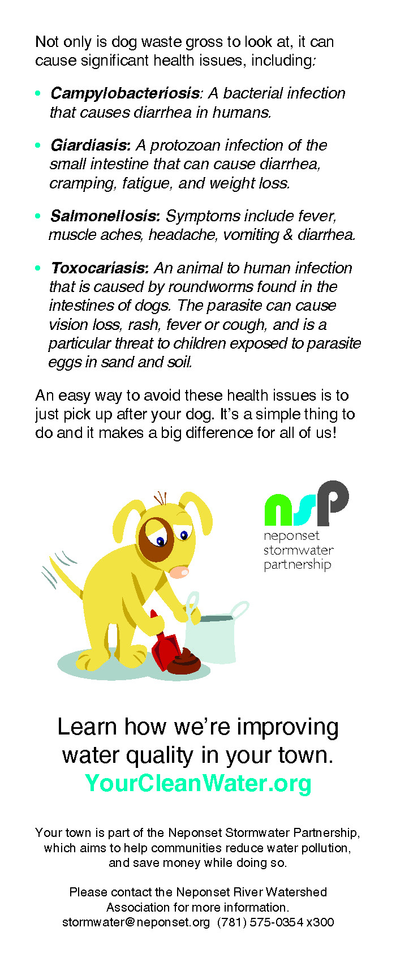
Contents: Rack Card Included with Dog Licenses
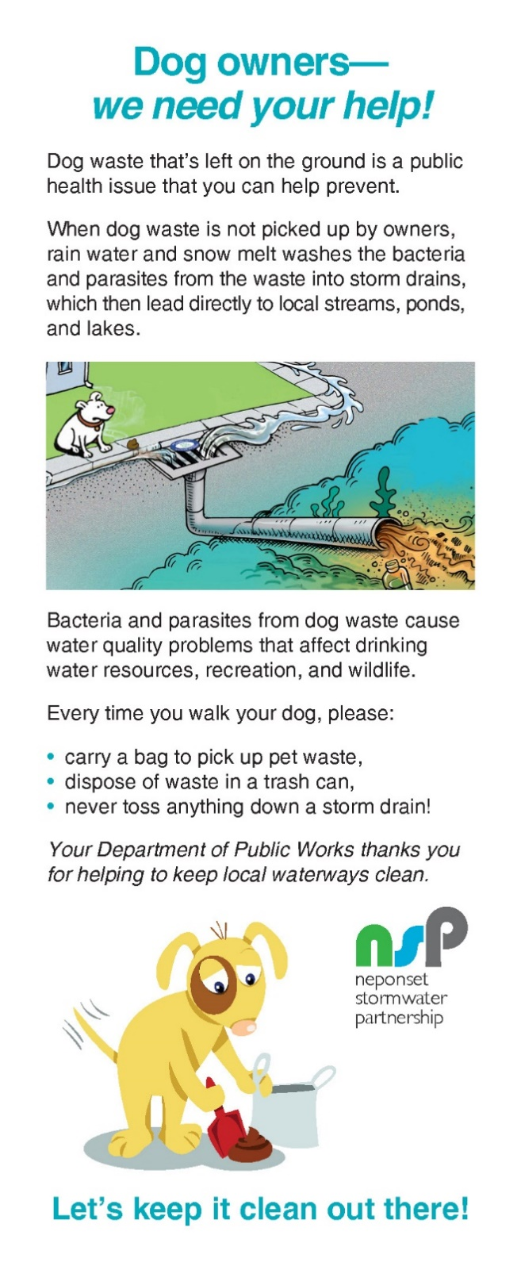

Appendix A-2: Example Materials for Public Education BMP 4

Contents: Facebook Ad/Campaign, Twitter, and Instagram Social Media Graphics
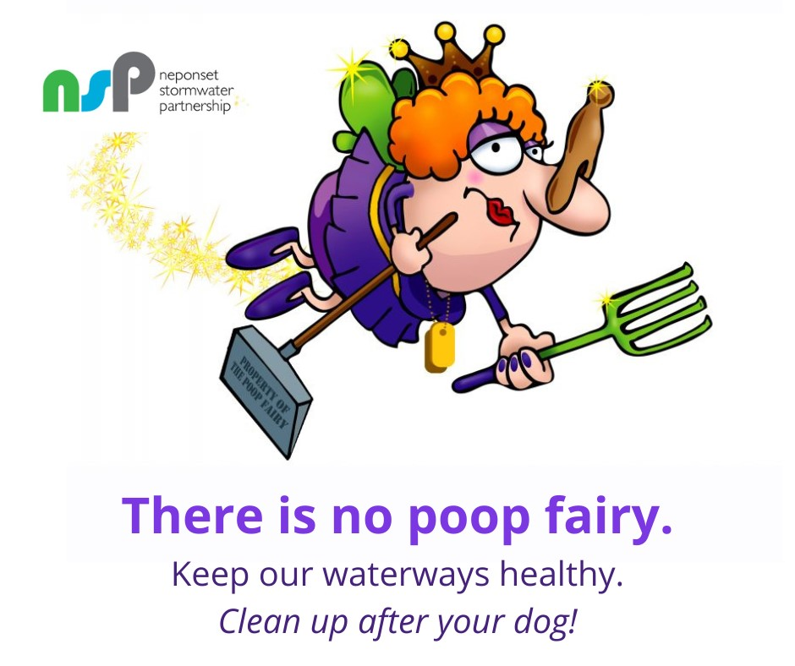

Image 1: Graphic used for Facebook Ad/Campaign, Facebook post, Instagram Post, and Twitter Post (July 12, 2022)

Appendix A-3: Example Materials for Public Education BMP 5

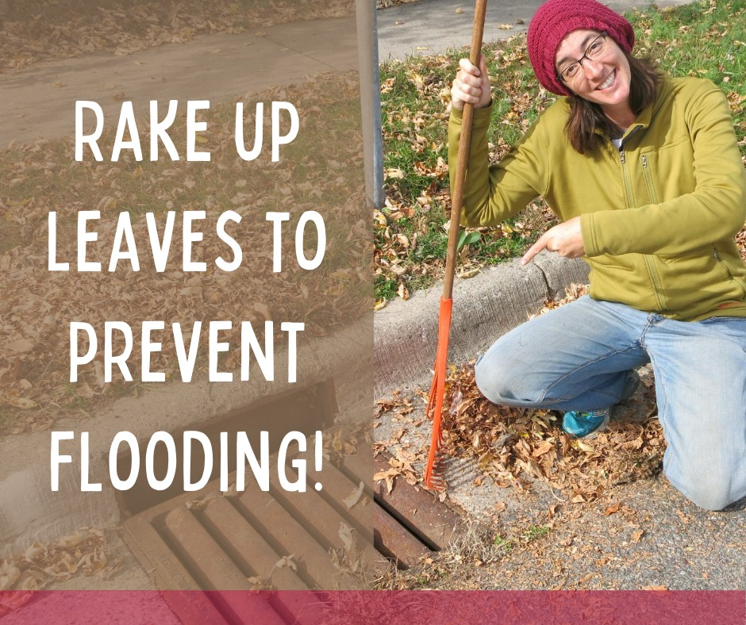
Photo 1: Graphic used for Facebook Ad/Campaign, Instagram Post (October 5, 2022), and Twitter Post (October 5, 11, and 17, 2022)
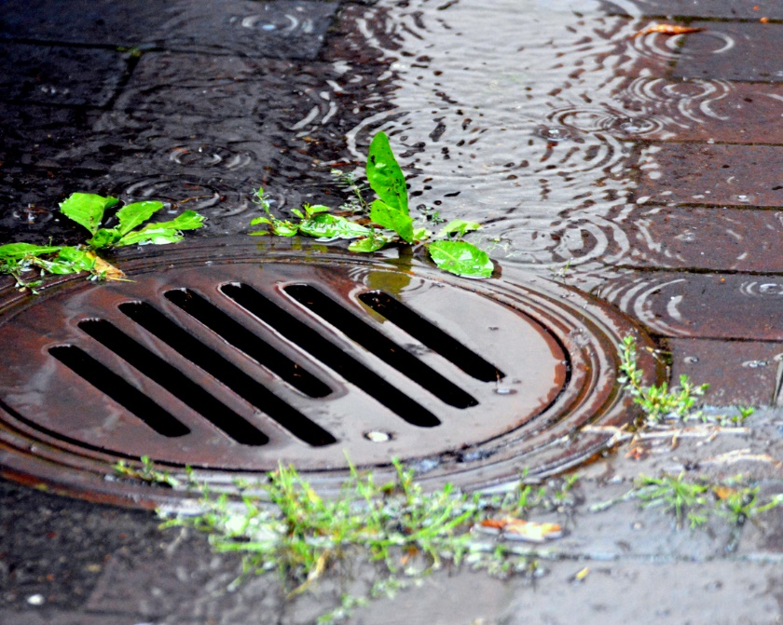

Photo 2: Graphic used for Facebook and Instagram Ad/Campaign for the Town of Walpole
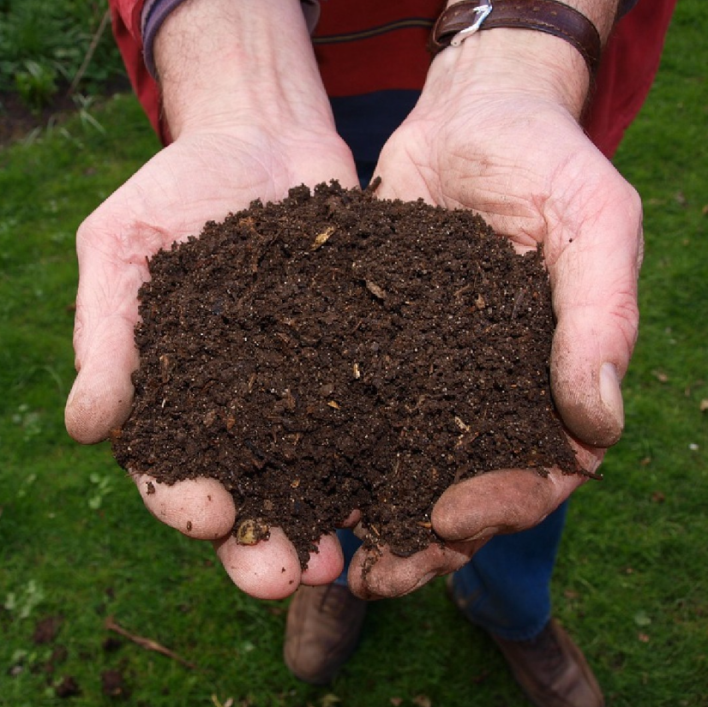
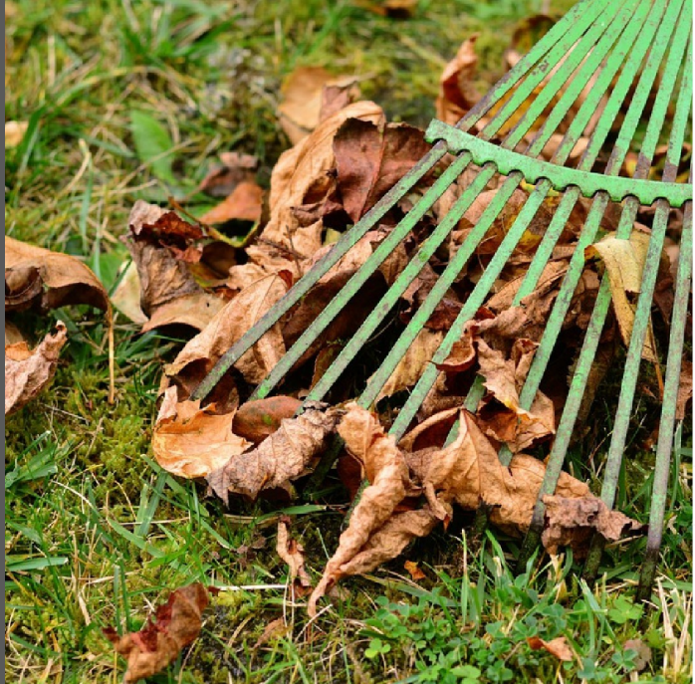
Photo 3 (left): Instagram graphic used for post on October 11, 2022.
Photo 4 (right): Facebook and Instagram graphic used for post on October 17, 2022.

Appendix A-4: Example Materials for Public Education BMP 6

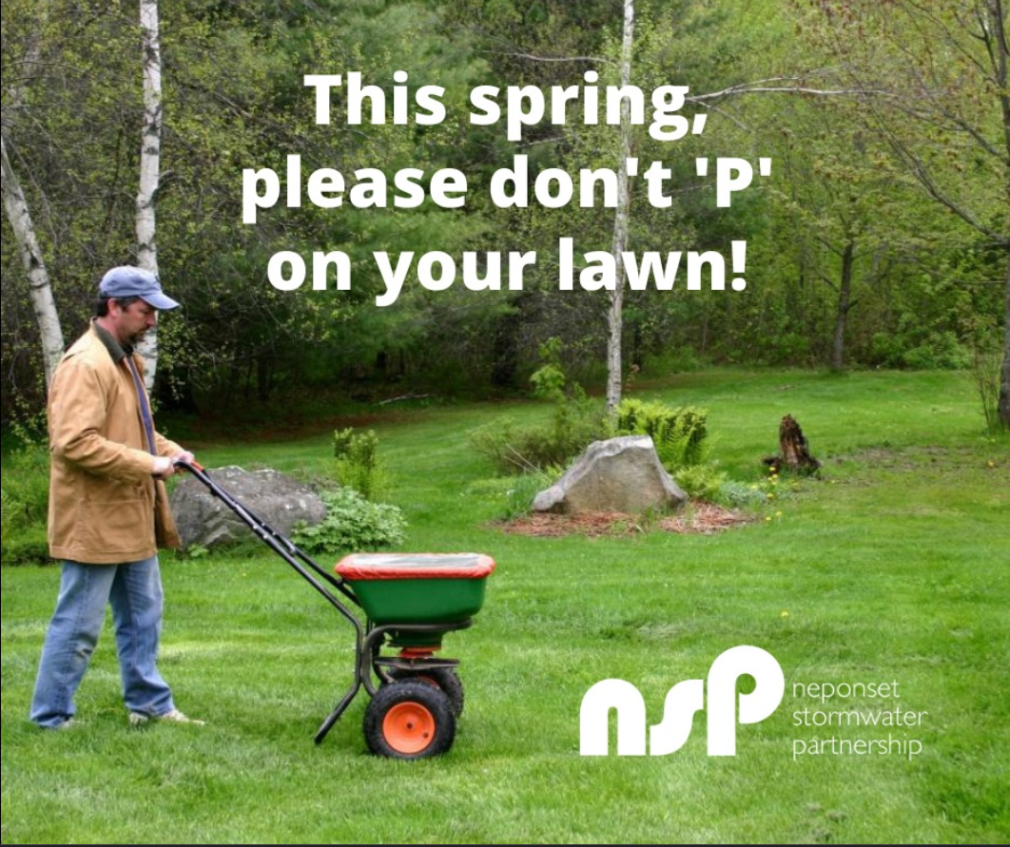
Photo 1: Graphic used for Facebook Ad/Campaign, Instagram Post (April 10, 2023), and Twitter Post (April 10 and 20, 2023)

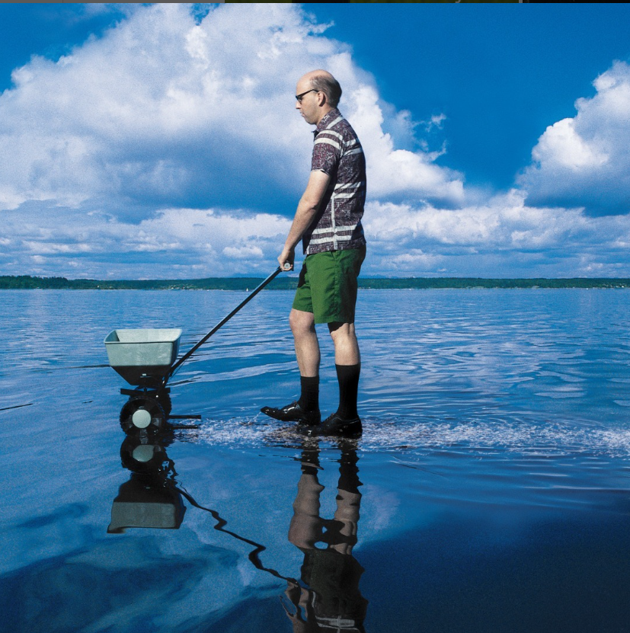

Photo 2: Instagram graphic used for post on April 20, 2023

Appendix A-5: Example Materials for Public Education BMP 7

Hand out for students to take home.

Appendix A-6: Example Materials for Regional Education Mailing BMP 8

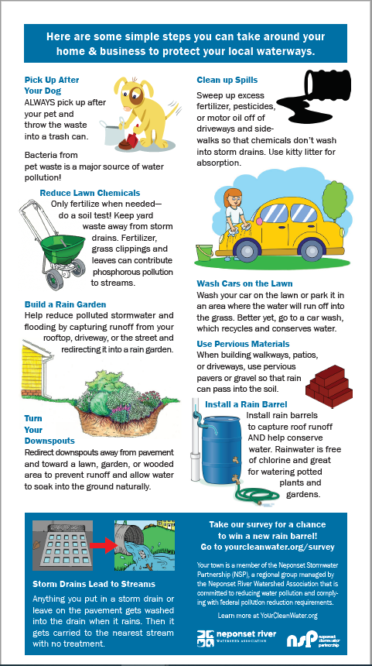
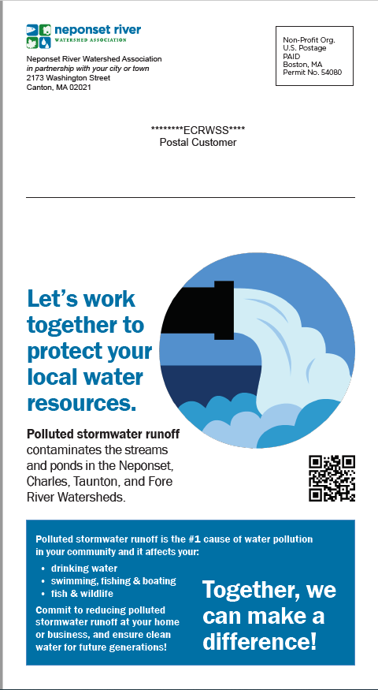

Appendix A-7: Outreach to Septic System Owners BMP 9

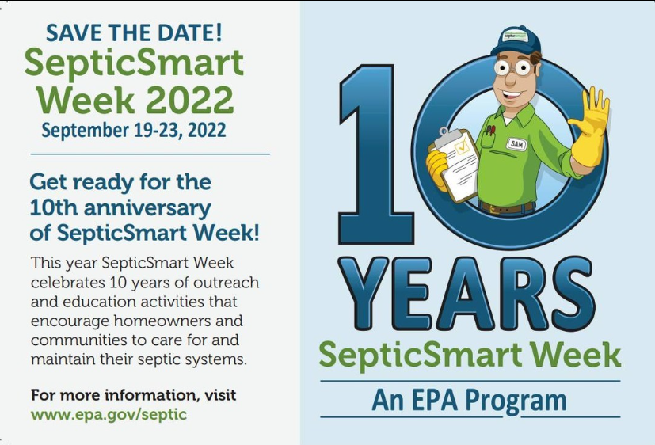

Photo 1: Facebook and Instagram graphic used on September 19, 2022
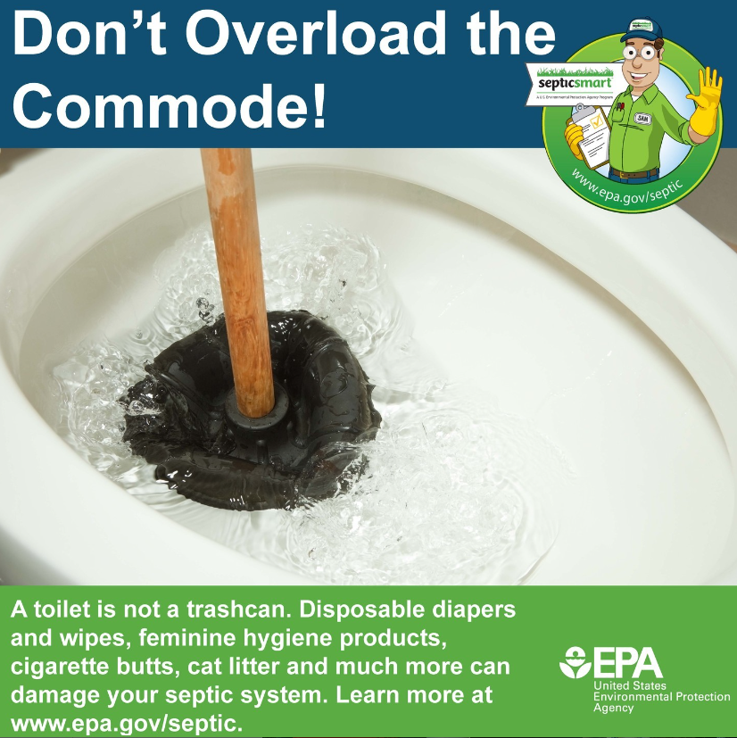

Photo 2: Facebook and Instagram graphic used on September 20, 2022

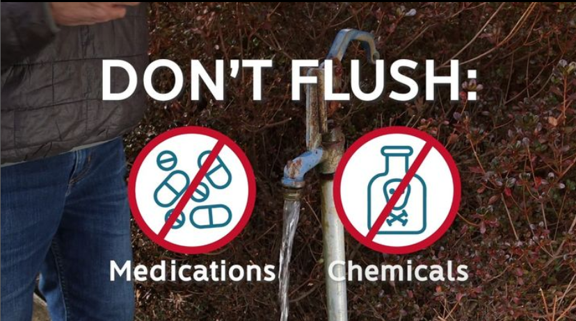
Photo 3: Instagram graphic used on September 21, 2022
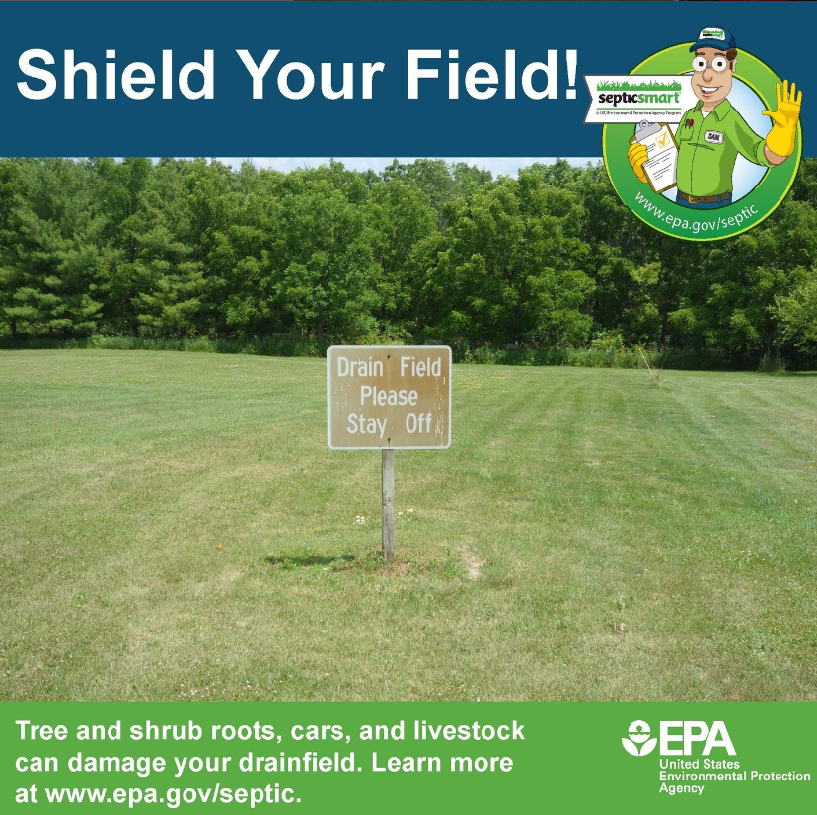

Photo 4: Instagram graphic used on September 22, 2022
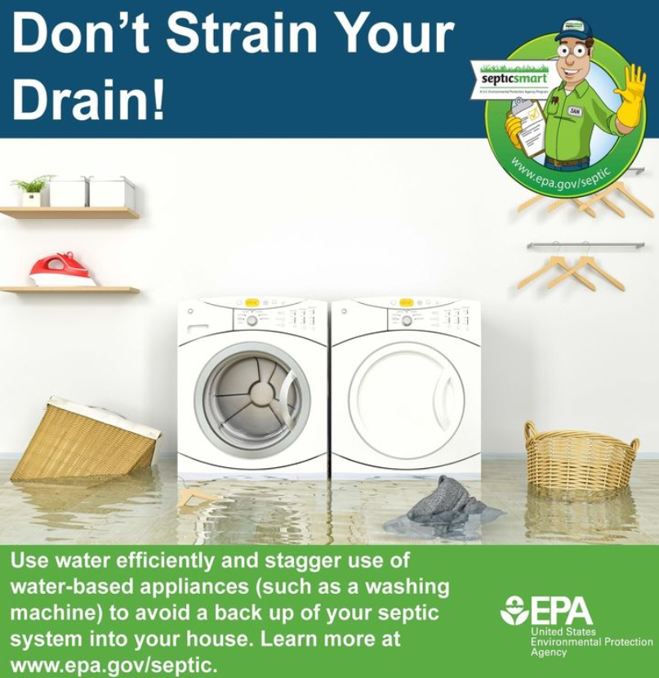
Photo 5: Facebook and Instagram graphic used on September 23, 2022

Appendix A-8: Example Materials for Public Education BMP 10

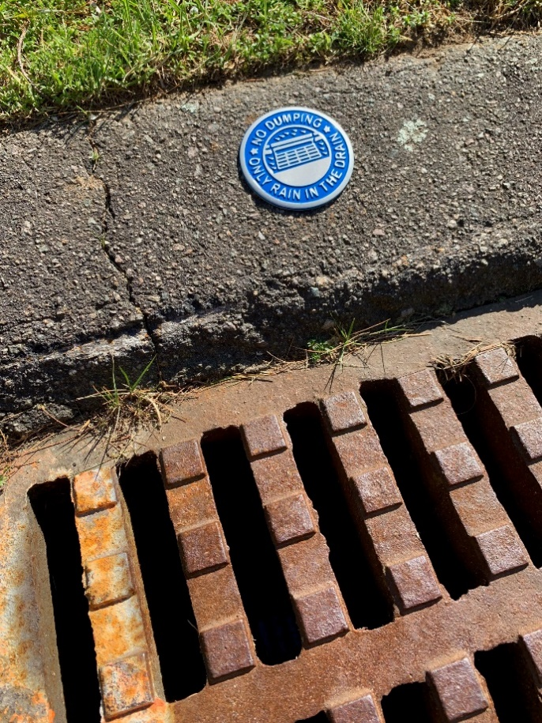
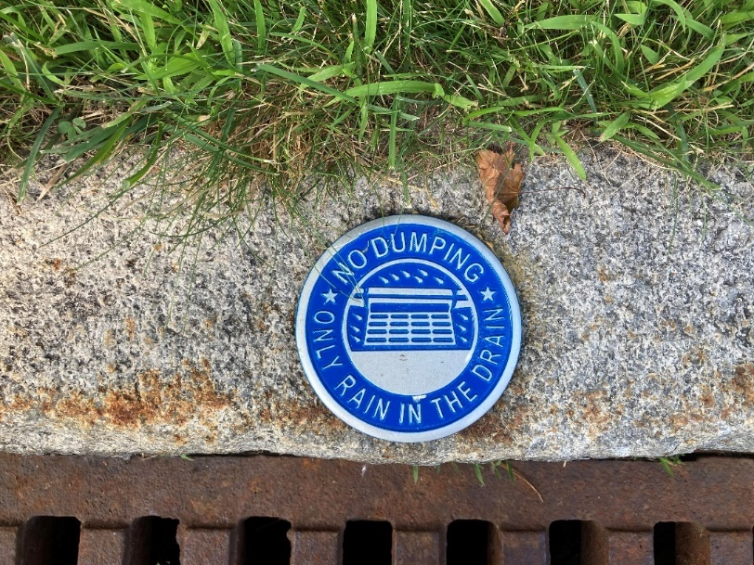

Appendix A-9: Example Materials for Public Education BMP 12

Appendix A-10: Example Materials for Public Education BMP 13

Appendix A-11: Example Materials for Public Education BMP 14

Appendix A-12: Example Materials for Public Education BMP 16/17

